<!DOCTYPE html>

<html lang="en">

<head>

    <meta charset="UTF-8">

    <meta name="viewport" content="width=device-width, initial-scale=1.0">

    <title>Document</title>

</head>

<body>

    <script>

        document.write("wao")

        var a=1;

        var b="two";

        var c=true;

        var d="thre";

        alert(b+d);

    </script>

</body>

</html>

For external add

We created file .js

In js document.write(“wao”)

Then in main file add

<script src=file.js>

</script>

If we don’t use var so its become global variable

<script>

    var b=3         //global

    function a(){

    document.write(b);

    d=2  //local        if we remove var before d its become global varibale

    }

    a()

    document.write(b);

    document.write(d);

array

  <script>

        var a=["nice","wise","rise","dice"]

        document.write(a);

        document.write("<br>");

        var b=[["nice","wise"],["rise","dice"]]

        document.write(b[1][0]);

    </script>

/* */

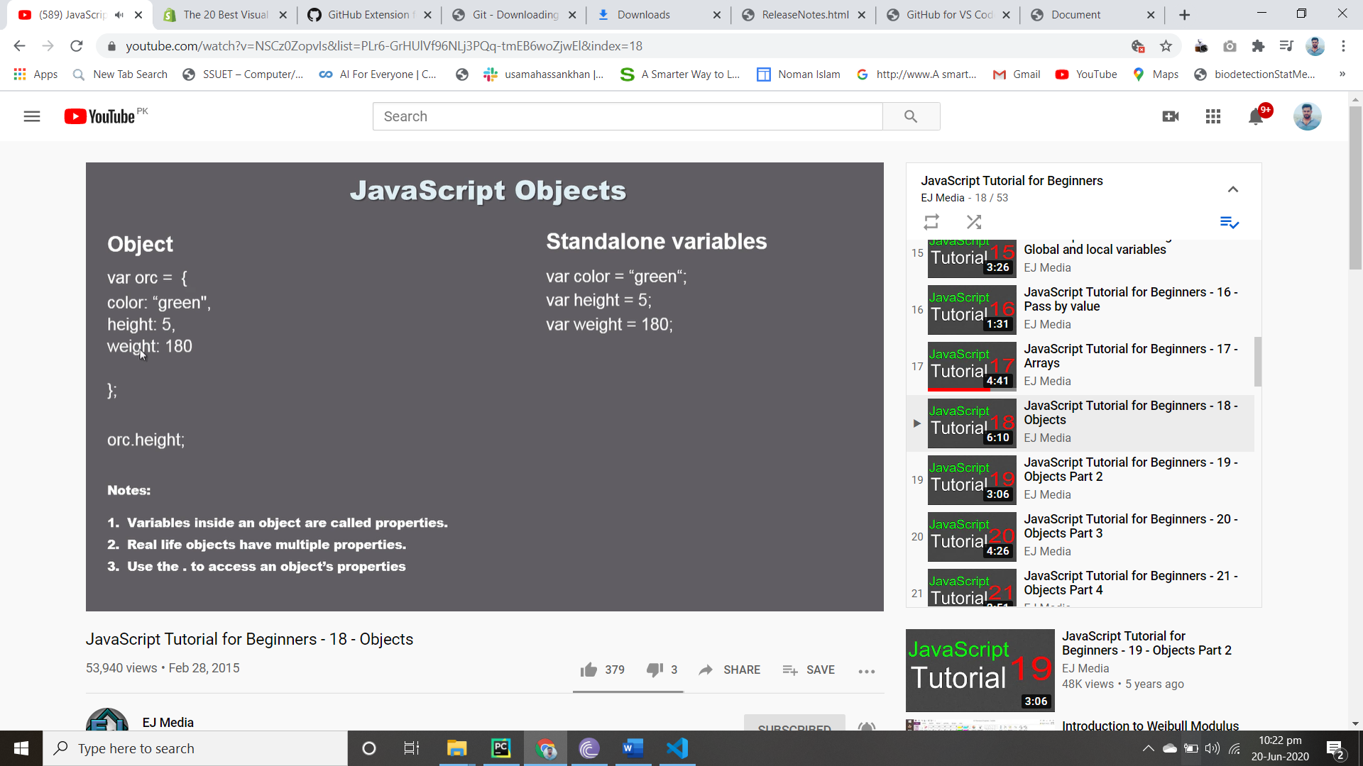

**Fuction in Objection**

 <script>

    var obj={

        color:1,

        size:3,

        name:"wap",

        wife:"rawao",

        yell:function(){

            document.write("its funcction f objct ");

        }

    }

    document.write(obj.color);

    obj.yell();

</script>

Delete and initialize again]

<script>

    var obj={

        color:1,

        size:3,

        name:"wap",

        wife:"rawao",

        yell:function(){

            document.write("its funcction f objct ");

        }

    }

    document.write(obj.color);

    obj.yell();

   document.write( obj.face="moo");

    delete obj.face;

    document.write( obj.face);

    delete obj.size

    document.write(obj.size);

</script>

Dom

<body>

    <p id="wao"> this is good </p>

    <button type="submit" ,onclick="a()">click kar</button>

    <script>

function a(){

    document.getElementById("wao").style.color="blue";

}

</script>

Dom by tagname

<body>

    <p class="po"> this is p 1</p>

    <p class="po"> this is p 2</p>

    <p class="po"> this is p 3</p>

    <p class="po"> this is p 4</p>

    <button onclick="fl()"> click</button>

    <button onclick="cl()"> click class</button>

    <script>

function fl(){

    var paragraph =document.getElementsByTagName("p");

    var paragraphtext=paragraph[0].style.fontStyle="italic";

    var paragraphtext=paragraph[1].style.color="pink";

    var paragraphtext=paragraph[2].style.color="red";

    var paragraphtext=paragraph[3].style.color="orange";

}

Classname dom

function cl(){

    var paragraph =document.getElementsByClassName("po");

    var paragraphtext=paragraph[0].style.fontStyle="italic";

    var paragraphtext=paragraph[1].style.color="pink";

    var paragraphtext=paragraph[2].style.color="red";

    var paragraphtext=paragraph[3].style.color="orange";

}

    </script>

Inner html use to change or edit text of html

<body>

    <p class="po"> this is p 1</p>

    <p class="po"> this is p 2</p>

    <p class="po"> this is p 3</p>

    <p class="po"> this is p 4</p>

    <button onclick="fl()"> click</button>

    <script>

function fl(){

    var paragraph =document.getElementsByTagName("p");

    var paragraphtext=paragraph[0].innerHTML="this is edited p1";

    var paragraphtext=paragraph[1].innerHTML="this is edited p2";

    var paragraphtext=paragraph[2].innerHTML="this is edited p3";

    var paragraphtext=paragraph[3].innerHTML="this is edited p4";

}

</script>

</body>

Retrive value and add

<body>

    <p class="po"> this is p 0</p>

    <p class="po"> this is p 1</p>

    <p class="po"> this is p 2</p>

    <p class="po"> this is p 3</p>

    <p class="po"> this is p 4</p>

    <p class="po"> this is p 5</p>

    <p class="po"> this is p 6</p>

    <p class="po"> this is p 7</p>

    <button onclick="fl()"> click</button>

    <script>

function fl(){

    var paragraph =document.getElementsByTagName("p");

    var paragraphtext=paragraph[0].innerHTML="this is edited p1";

    var paragraphtext=paragraph[1].innerHTML="this is edited p2";

    var paragraphtext=paragraph[2].innerHTML="this is edited p3";

    var paragraphtext=paragraph[3].innerHTML="this is edited p4";

    var paragraphtext1=paragraph[5].innerHTML;

    var paragraphtext2=paragraph[6].innerHTML;

    paragraph[7].innerHTML=paragraphtext1+paragraphtext2;

}

</script>

Mouse over

<!DOCTYPE html>

<html lang="en">

<head>

    <meta charset="UTF-8">

    <meta name="viewport" content="width=device-width, initial-scale=1.0">

    <title>Document</title>

    <script>

        function tp(){

            document.getElementById("a").style.backgroundColor="red";

        }

        function b(){

            document.getElementById("a").style.backgroundColor="";

        }

    </script>

</head>

<body>

    <p id="a" onmouseover="tp() " onmouseout="b()">this is</p>

</body>

</html>

Image hover

<script>

        function as(){

document.getElementById("a").src="old.jpeg";

        }

        function an(){

document.getElementById("a").src="new.jpg";

        }

    </script>

</head>

<body>

    <img height="400px" id="a" onmouseover="as()" onmouseout="an()" src="new.jpg">

</body>

Read more

Add paragraphs

 <script>

        function  ans(){

            var element=document.createElement("p");

            var mains=document.getElementById("main");

            mains.appendChild(element);

            var text=document.createTextNode("this is faaioadn adfadiod sdfonskf ssoda adaofjda daadofmad daadoadpadd fadfadnad ad,ddn fdadad f<br>abibf adao daodandkn aalnlanala aaala");

   element.appendChild(text);

        }

    </script>

Main is id used in div

And ans os event name onn click use in button

Div is parent

P in div is child

**Appendchild()** for append

**Create element()** **for create new element**

**CreateTextNode() for create text**

Add heading

   function  ans(){

            var elements=document.createElement("h2");// for  add heading

            var main=document.getElementById("main");

            main.appendChild(elements);

            var texts=document.createTextNode("this is mongol  war ");

   elements.appendChild(texts);

}

Dlt heading and paragraph

    function del(){

               var el=document.getElementsByTagName("h1")[2];

               var dol=el.parentNode;

               dol.removeChild(el);

               var els=document.getElementsByTagName("p")[4];

               var dols=els.parentNode;

               dols.removeChild(els);

        }

Set attribute

var attr=document.createAttribute("id");

attr.value="txt";

elements.setAttributeNode(attr);

txt is id and u have to give css of this id which u want

if u want to change attribute last ist etc so it will

    function firstelement(){

var parent =document.getElementById("main");

var child=parent.lastElementChild;

child.style.color="blue";

}

If u use []

It pick all space no each for node

Change parent node attributes

function whole(){

    ct=document.getElementById("po”)

    var b=ct.parentNode;

    b.style.color="red";}

Po is child node div

Sibling

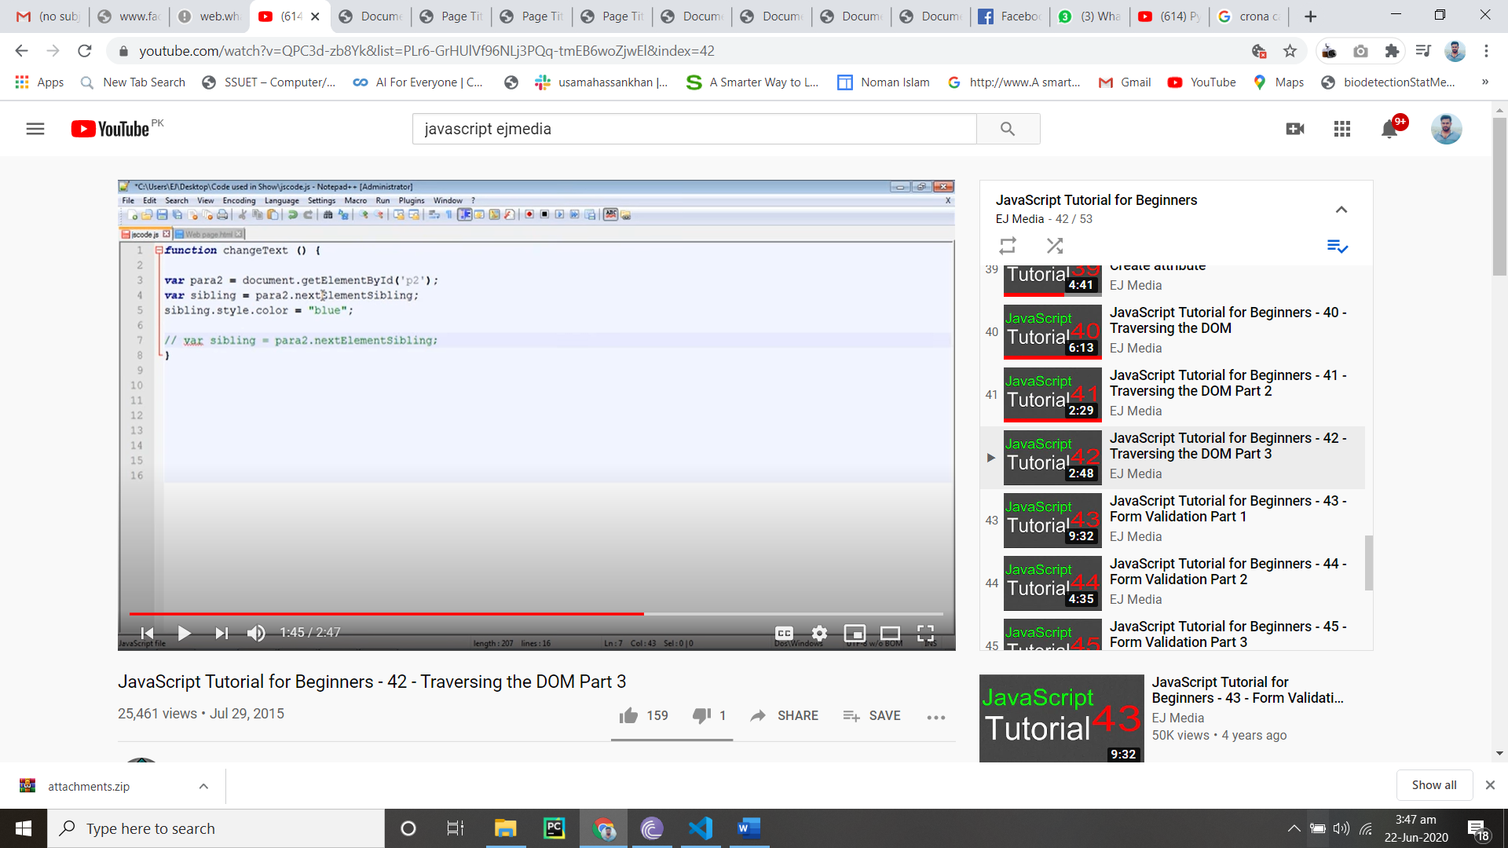

Sibling element

If u use id so which is in ur previous so it will

function sibling(){

    var ct=document.getElementById("po")

    var siblings=ct.previousElementSibling;

    siblings.style.color="red";

    var siblingsend=ct.nextElementSibling;

    siblingsend.style.color="pink";

}

Validation

function validation(){

var box=document.getElementById("name");

if (box.value==""){

alert("please enter name");

box.focus();

box.style.border="solid 3px  red";

return false;

}

Addition and button hidden

Var a=(“enter message”)

If(a==true)

   <script>

       function funct(){

           var confirmation=confirm("these changes are final");

           if(confirmation==true){

        var a= document.getElementsByClassName("para");

        var first=a[0].innerHTML;

        var second=a[1].innerHTML;

        var sum=a[2].innerHTML=first+second;

        var first=a[0].innerHTML="";

        var second=a[1].innerHTML="";

        document.getElementById("test").style.visibility="hidden";

        }}

    </script>

</head>

<body>

    <p class="para"> this is one</p>

    <p class="para"> this is two</p>

    <p class="para"></p>

    <button  id ="test" onclick="funct()"> this is wonderfull</button>

</body>

Function object

<body>

    <script>

        function vi(car,bike,jahaz){

            this.car=car;

            this.bike=bike;

            this.jahaz=jahaz;

        }

        var car1=new vi("honda","hayabusa3","jet1");

        var car3=new vi("honda1","hayabusa2","jet2");

        var car2=new vi("honda3","hayabusa2","jet4");

        document.write(car1.bike)

        function ab(){

            document.getElementById("text").innerHTML=car1.bike+car1.car+car1.jahaz;

        }

    </script>

    <p id="text">

    </p>

    <button onclick="ab()"> enter kar</button>

</body>

</html>

Move next page

<head>

    <meta charset="UTF-8">

    <meta name="viewport" content="width=device-width, initial-scale=1.0">

    <title>Document</title>

</head>

<body>

    <script>

        function next(){

            window.location="first.html"

        }

    </script>

<button onclick="next()">move next page</button>

</body>

Now this end of yoytbe practice

Now doing udemy javascript

Javascript shortcut

.classname enter tab so

<div class="test"></div>

.idname entre tab so

<div id="test"></div>

Undefined means nothing is return

// for single comment

/*

*/ for double line comment

Console .log for written in console

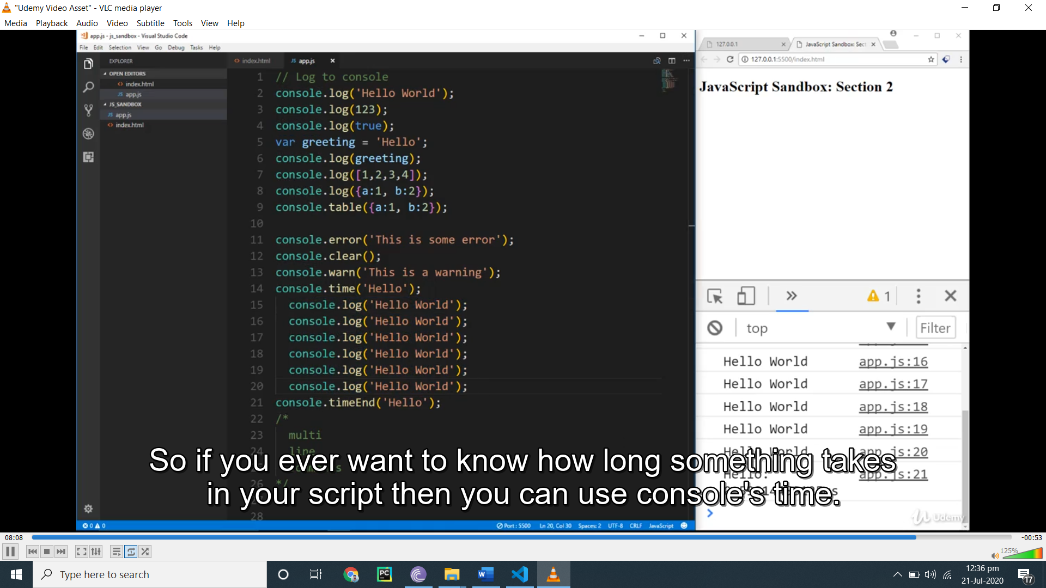

consle time and end time what u use between the tell hw much time It took

Console .table show in table

Var const and let we can initialize variable by three ways

Let variable can b change const cant change

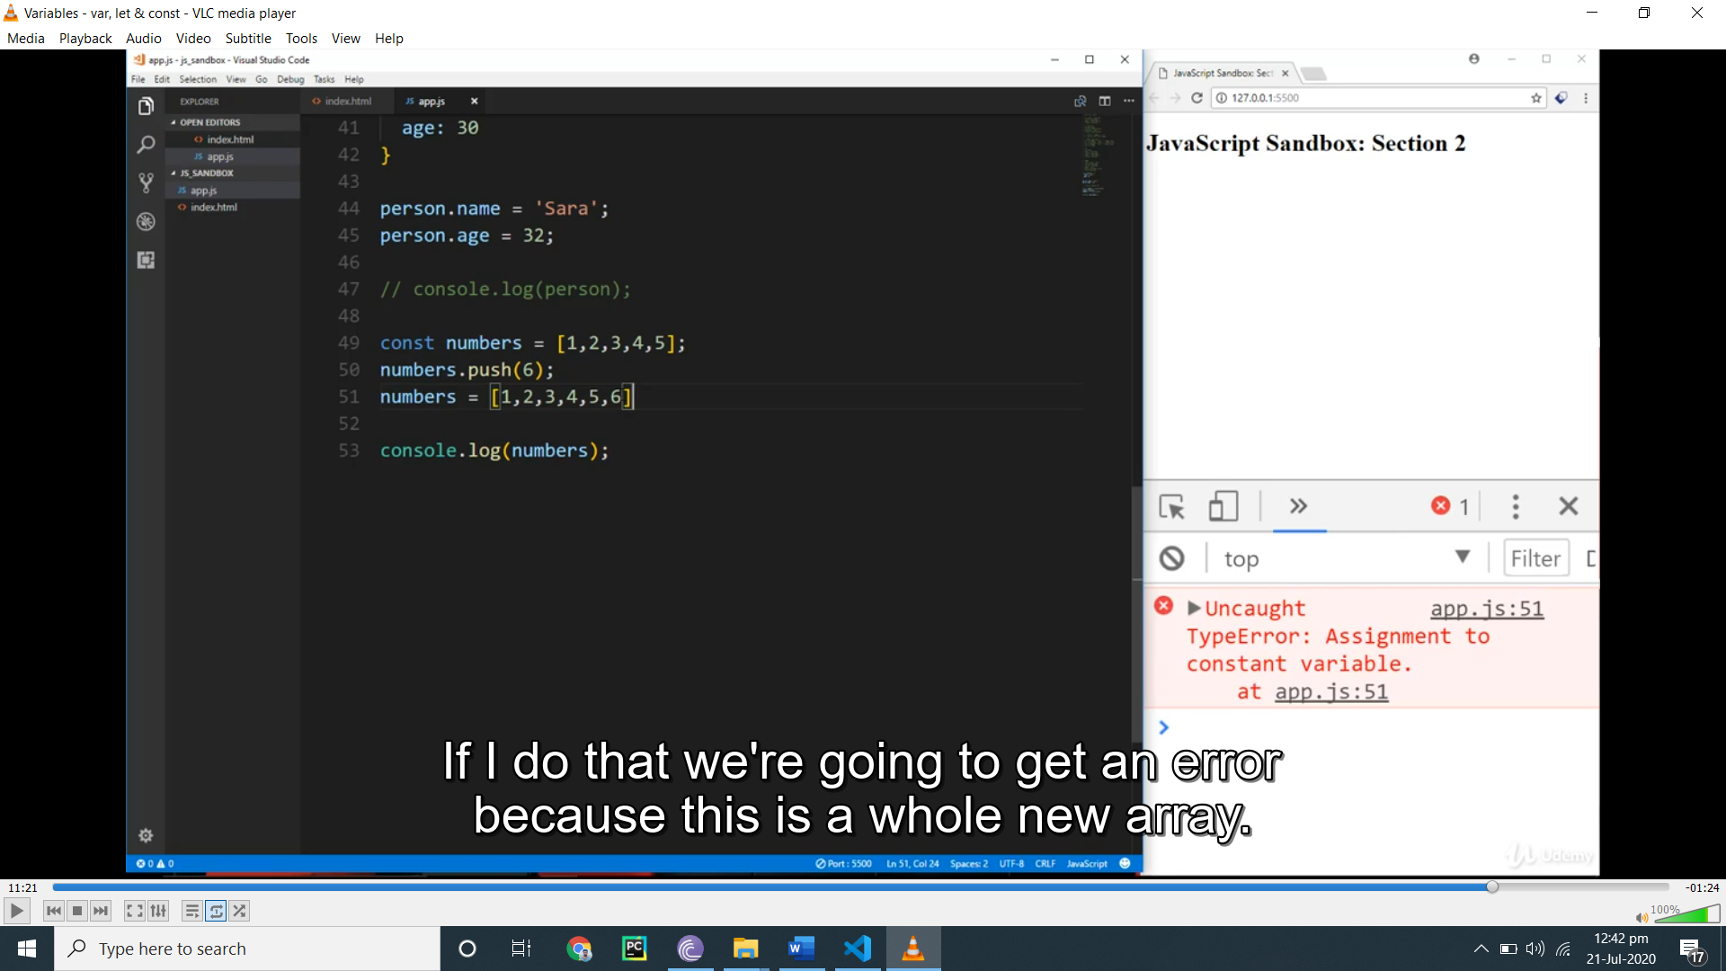

But we can add new item through const

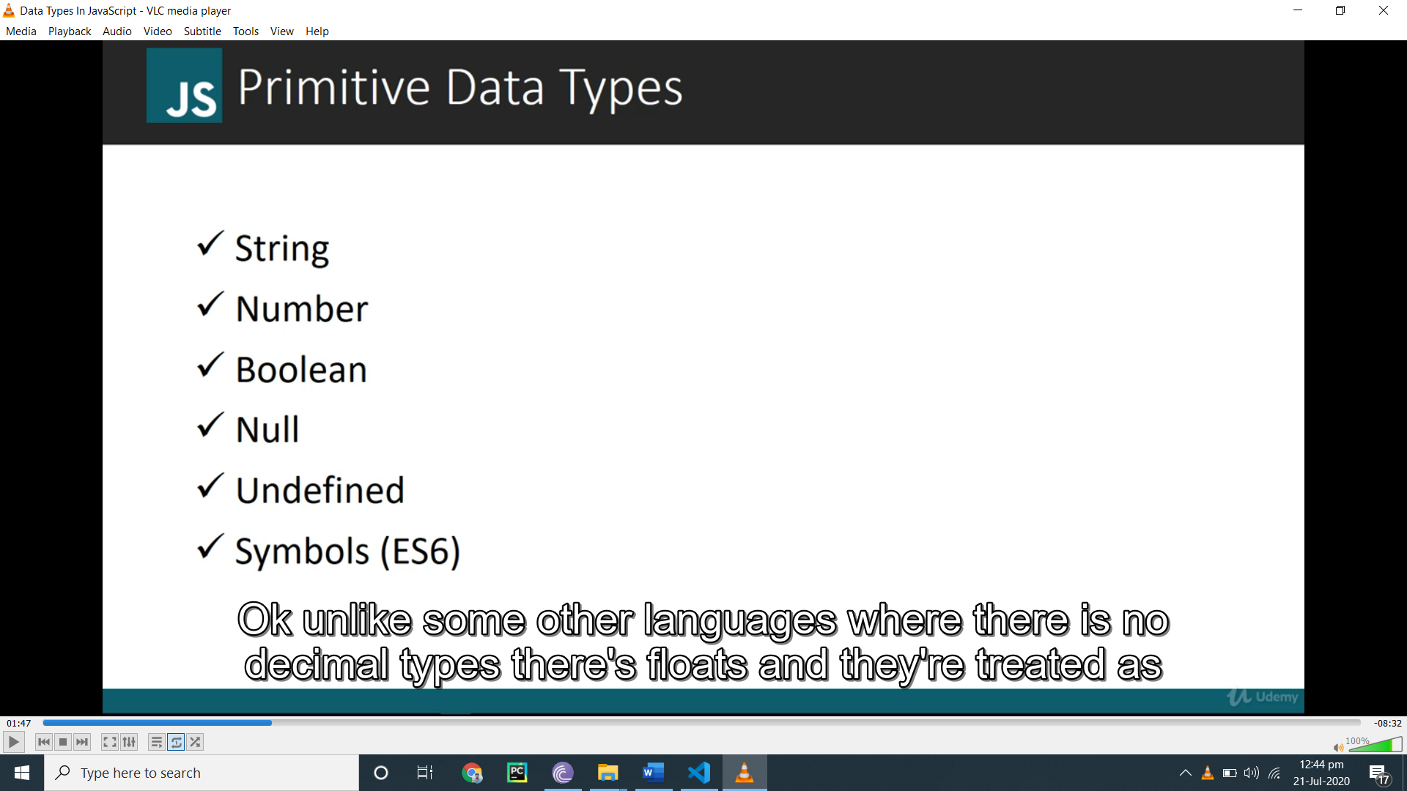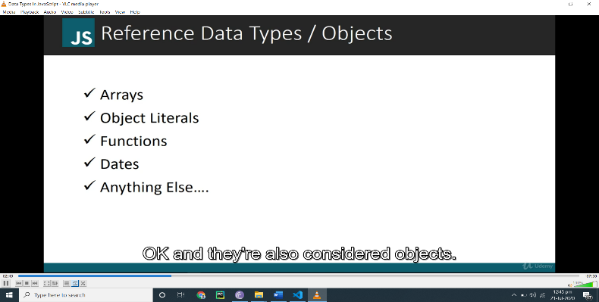

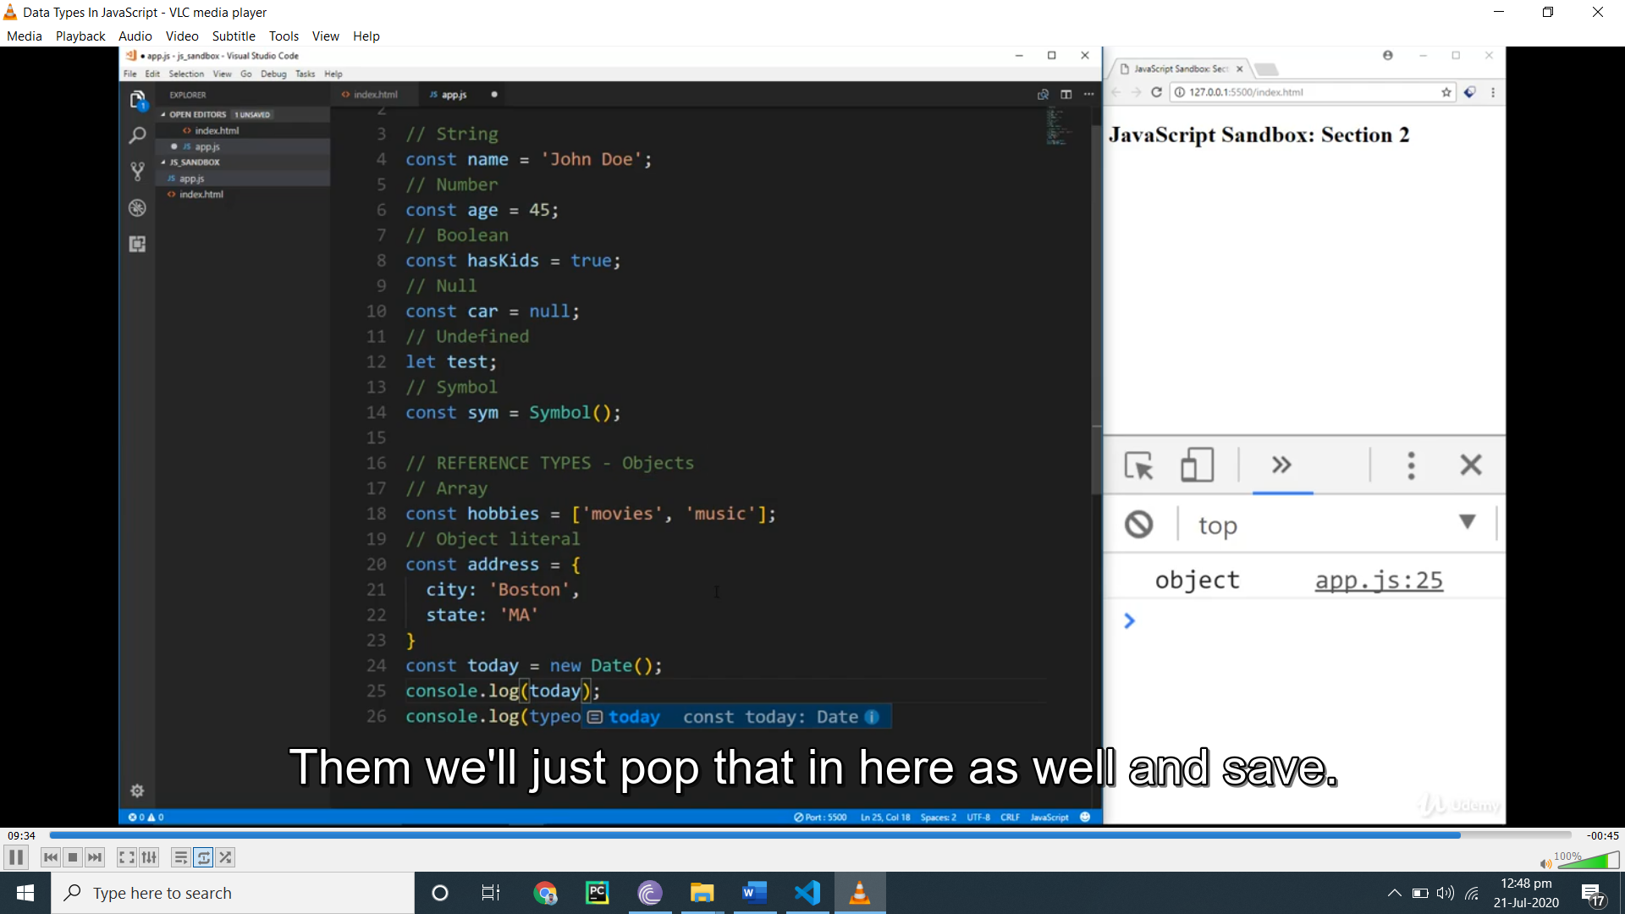

**Type conversion**

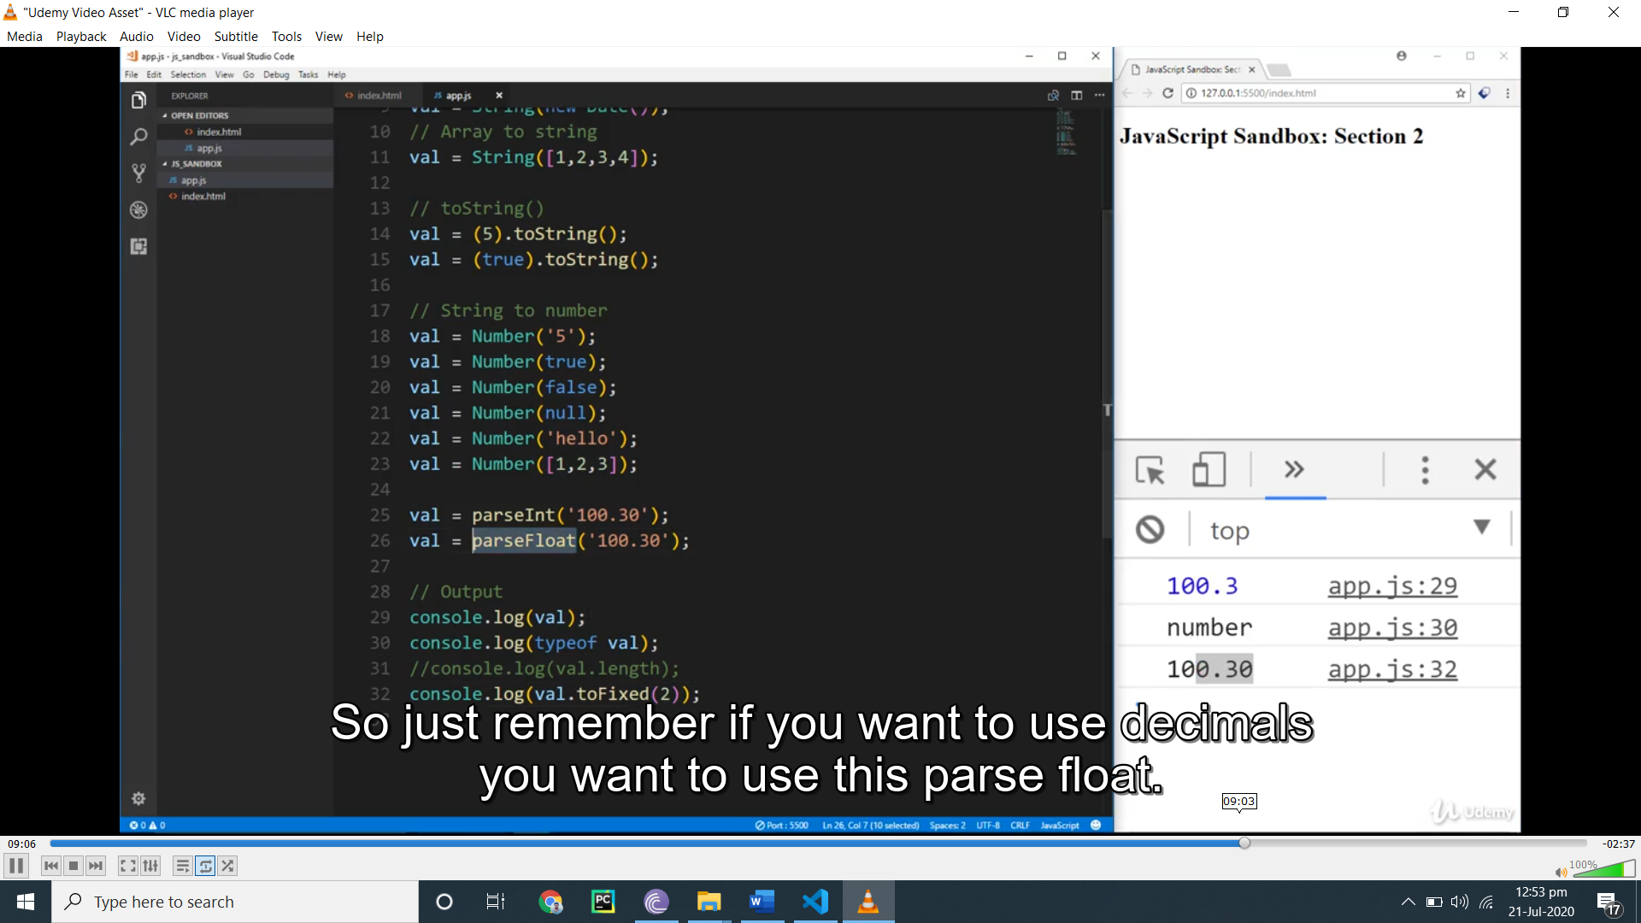

**Fo fixed(2) add 2 zero after point**

**Number function convert into number**

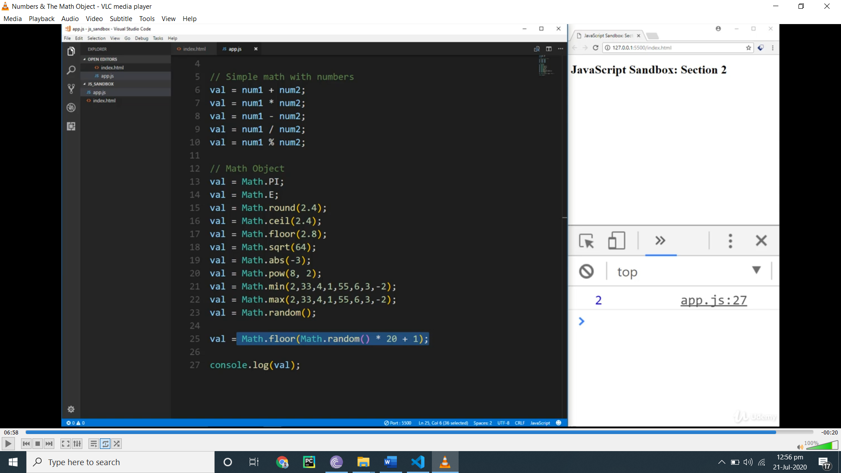

String manilplu

const firstName = 'William';

const lastName = 'Johnson';

const age = 36;

const str = 'Hello there my name is Brad';

const tags = 'web design,web development,programming';

**let val;**

**val = firstName + lastName;**

// Concatenation

val = firstName + ' ' + lastName;

// Append

val = 'Brad ';

val += 'Traversy';

val = 'Hello, my name is ' + firstName + ' and I am ' + age;

// Escaping

val =  'That\'s awesome, I can\'t wait';

// Length

val = firstName.length;

// concat()

val = firstName.concat(' ', lastName);

// Change case

val = firstName.toUpperCase();

val = firstName.toLowerCase();

val = firstName[2];

// indexOf()

val = firstName.indexOf('l');

val = firstName.lastIndexOf('l');// charAt()

val = firstName.charAt('2');

// Get last char

val = firstName.charAt(firstName.length - 1);

// substring()

val = firstName.substring(0, 4);

// slice()

val = firstName.slice(0,4);

val = firstName.slice(-3);

// split()

val = str.split(' ');

val = tags.split(',');

// replace()

val = str.replace('Brad', 'Jack');

// includes()

val = str.includes('foo');

console.log(val);

es5

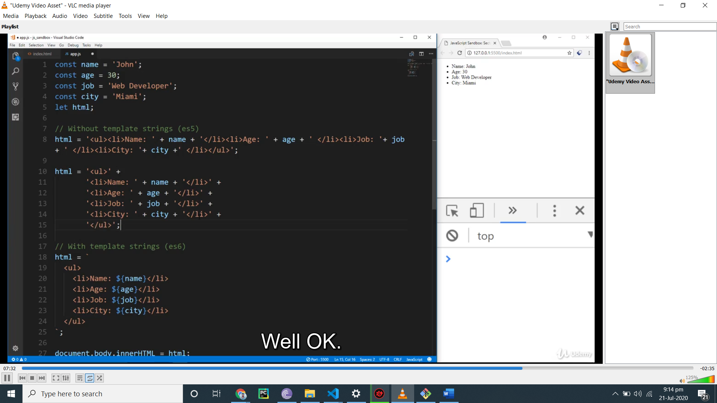

array

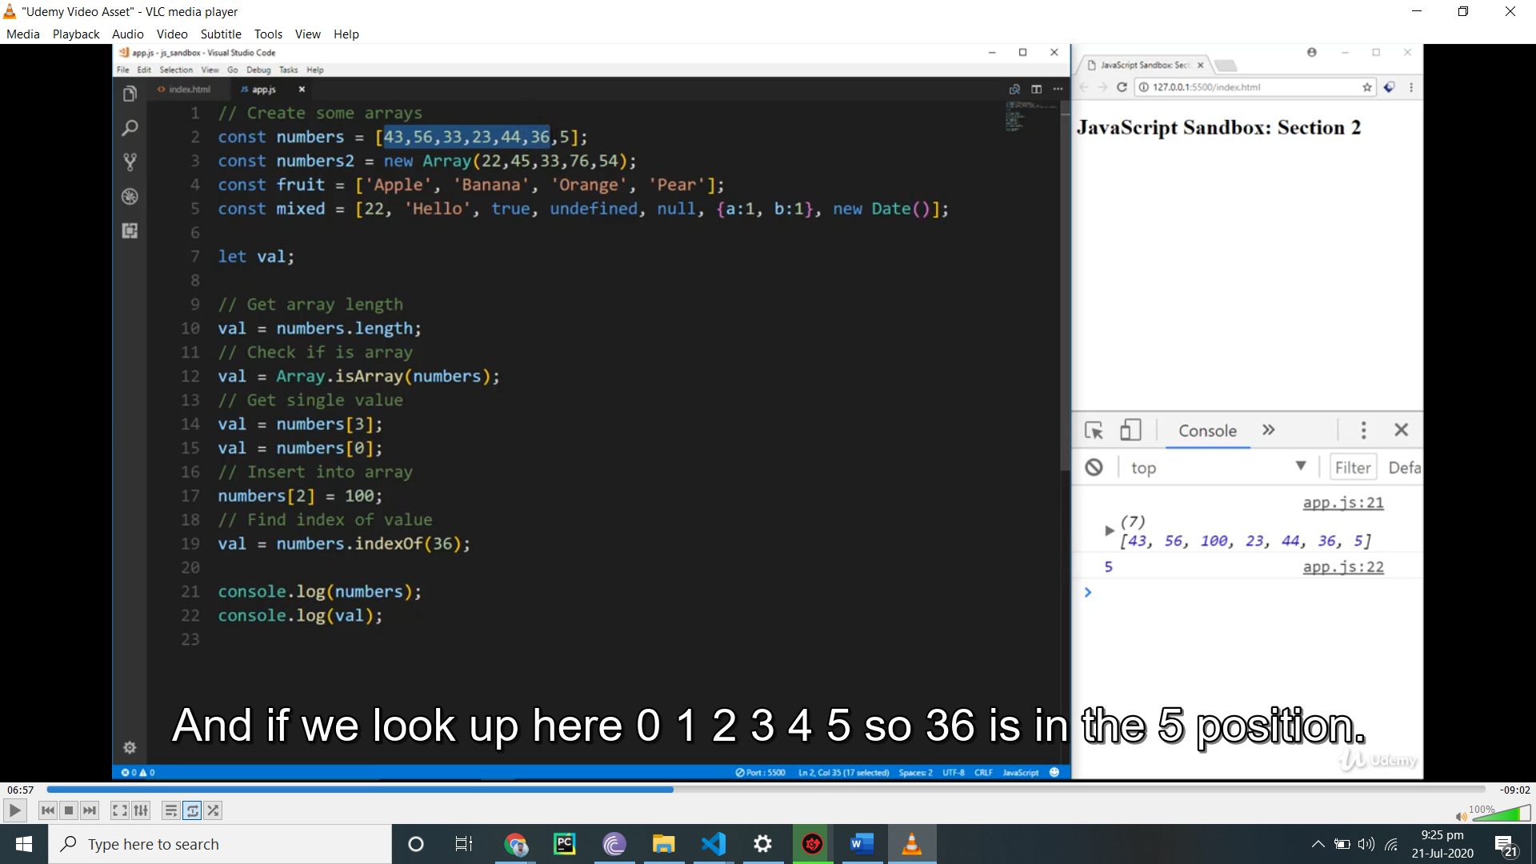

Numbers.pust(250)

It will append In last of array

Numbers.unshift(250) it will appent In ist

Numbers.pop()

Delet form last

Numbers.splice(1,3)

Dlt 1 ,2, index

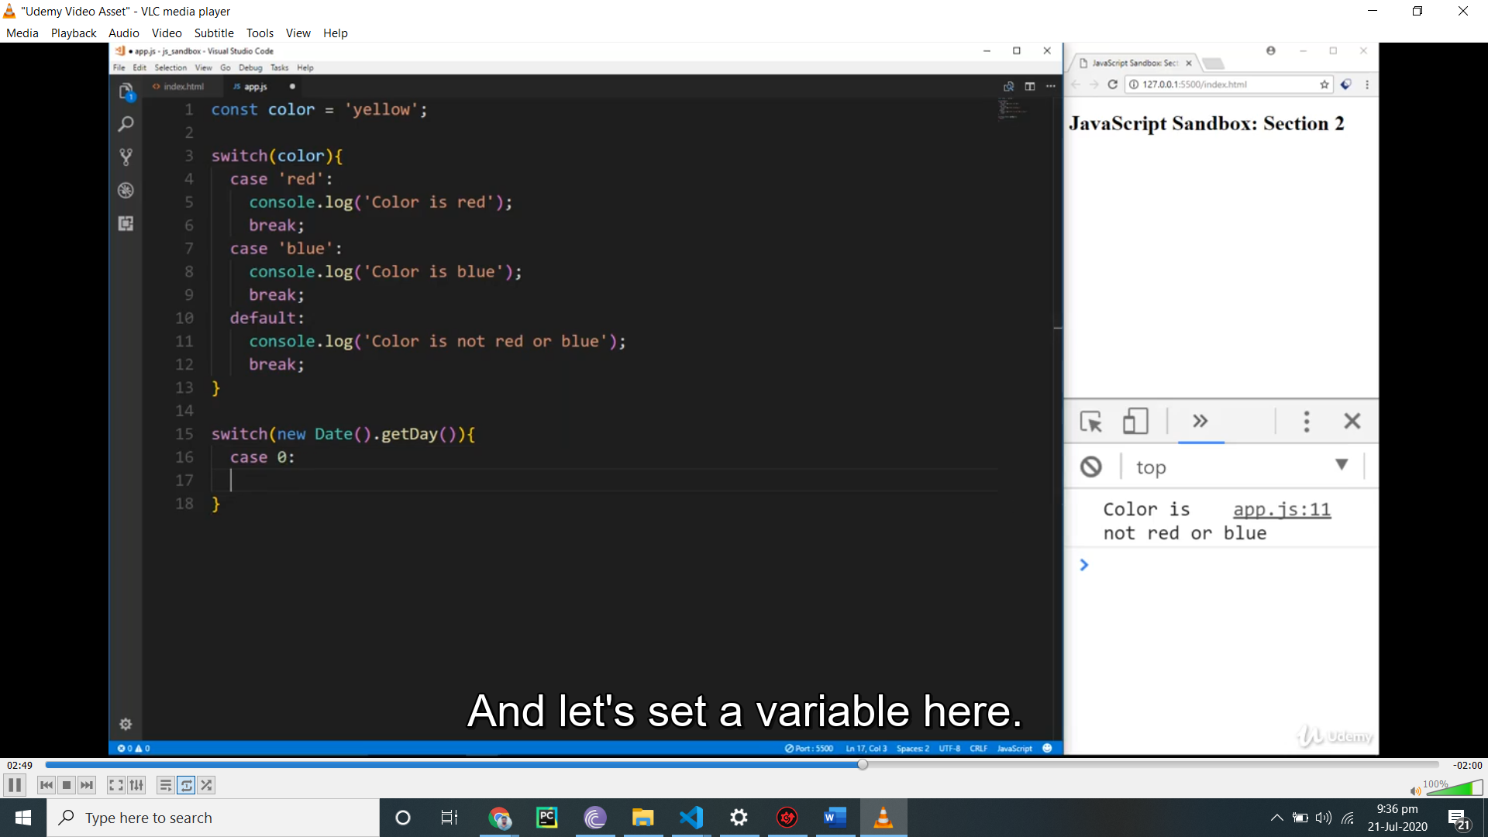



// WINDOW METHODS / OBJECTS / PROPERTIES

// Alert

//alert('Hello World');

// Prompt

// const input = prompt();

// alert(input);

// Confirm

// if(confirm('Are you sure')){

//   console.log('YES');

// } else {

//   console.log('NO');

// }

let val;

// Outter height and width

val = window.outerHeight;

val = window.outerWidth;

// Inner height and width

val = window.innerHeight;

val = window.innerWidth;

// Scroll points

val = window.scrollY;

val = window.scrollX;

// Location Object

val = window.location;

val = window.location.hostname;

val = window.location.port;

val = window.location.href;

val = window.location.search;

// Redirect

//window.location.href = 'http://google.com';

//Reload

//window.location.reload();

// History Object

// window.history.go(-2);

// val = window.history.length;

// Navigator Object

val = window.navigator;

val = window.navigator.appName;

val = window.navigator.appVersion;

val = window.navigator.userAgent;

val = window.navigator.platform;

val = window.navigator.vendor;

val = window.navigator.language;

console.log(val);

window.history.go(-2)means 2last search

localand global scope

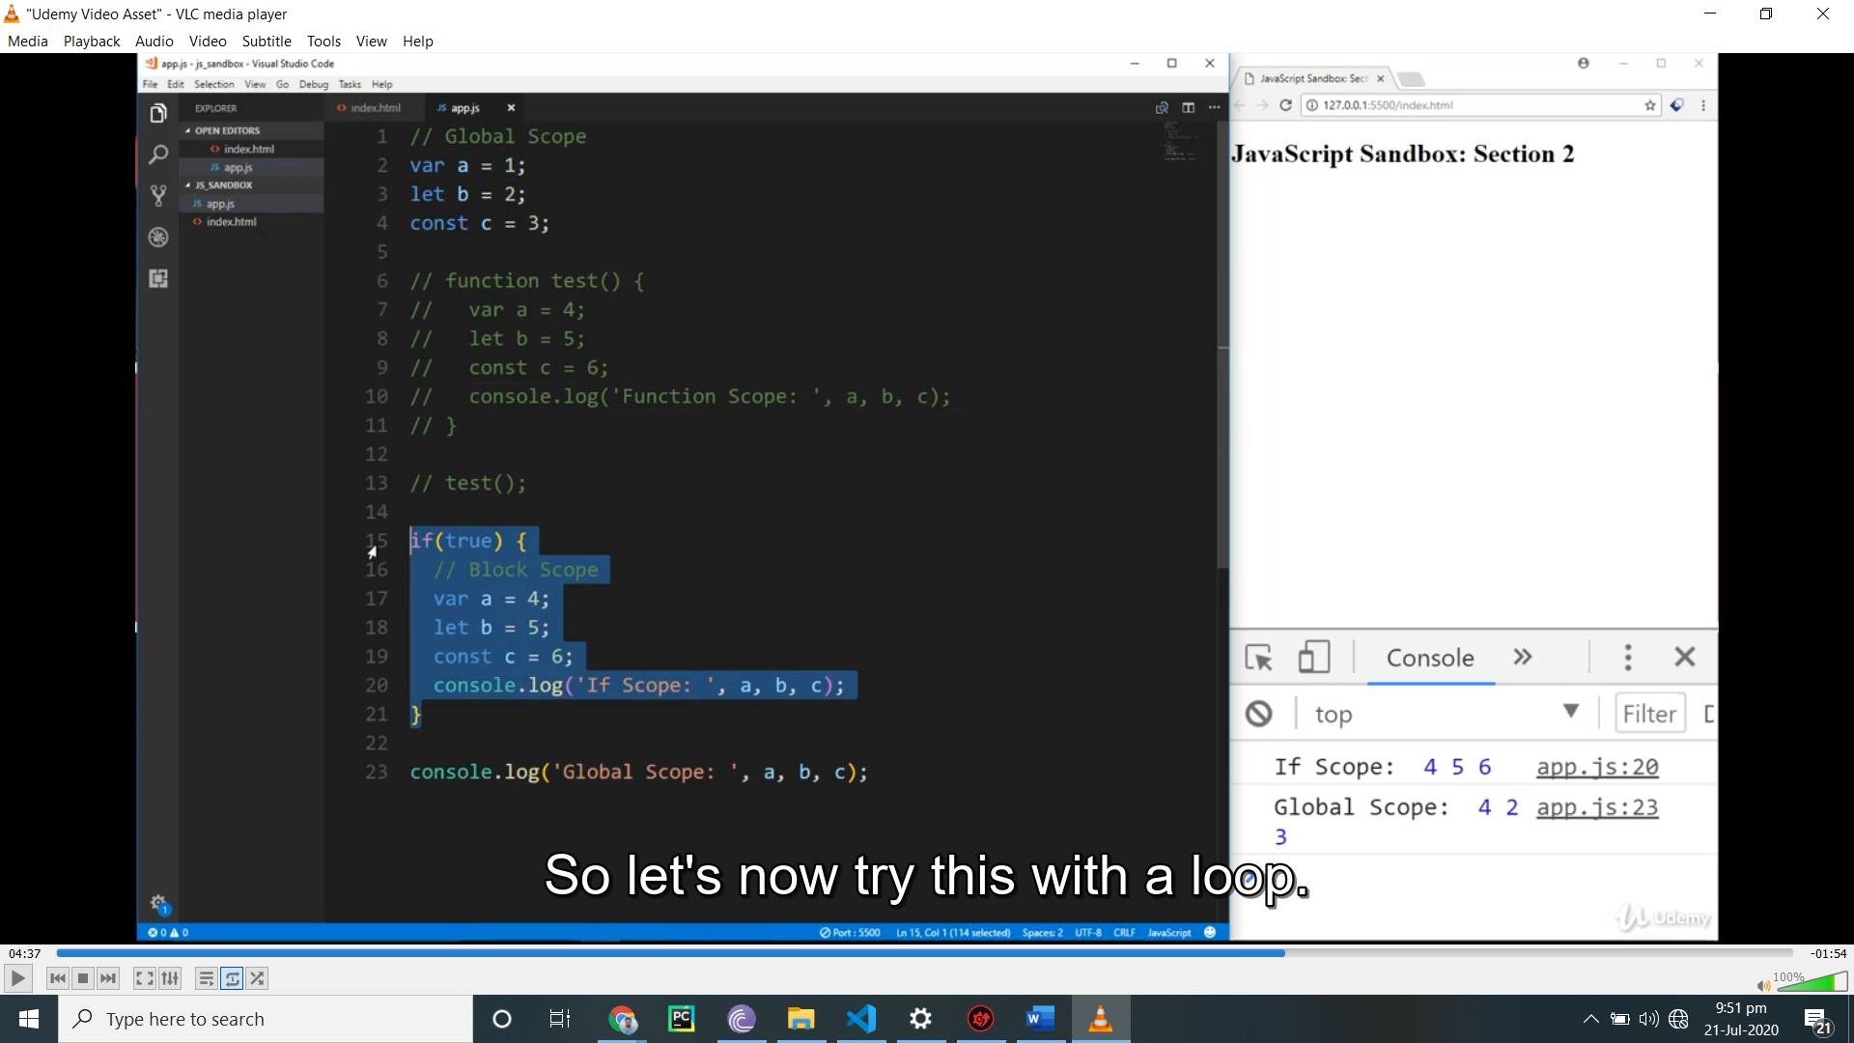

Let val;

Val=documents

Val =Document.all;

Console.log(val);

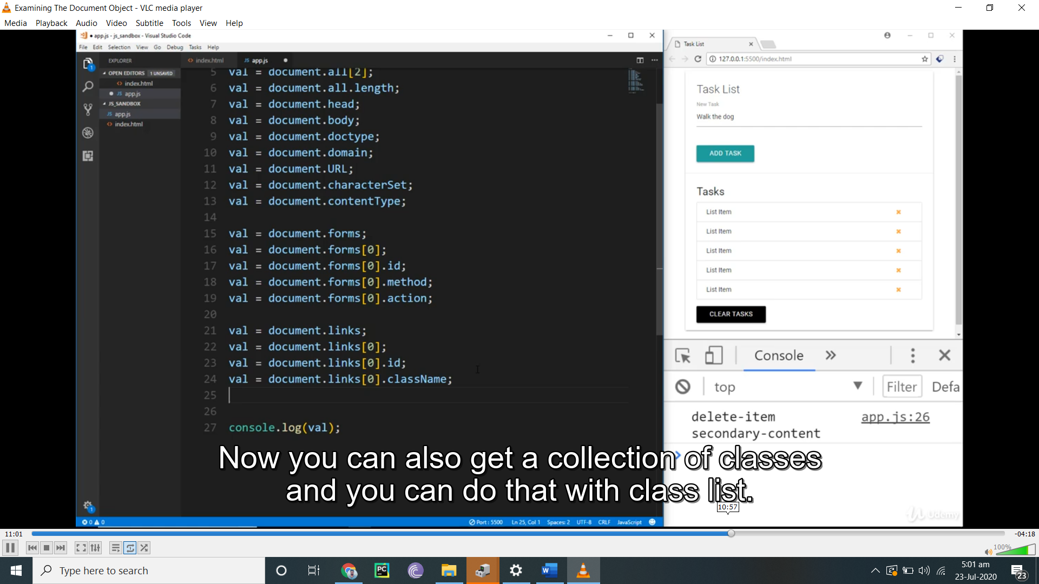

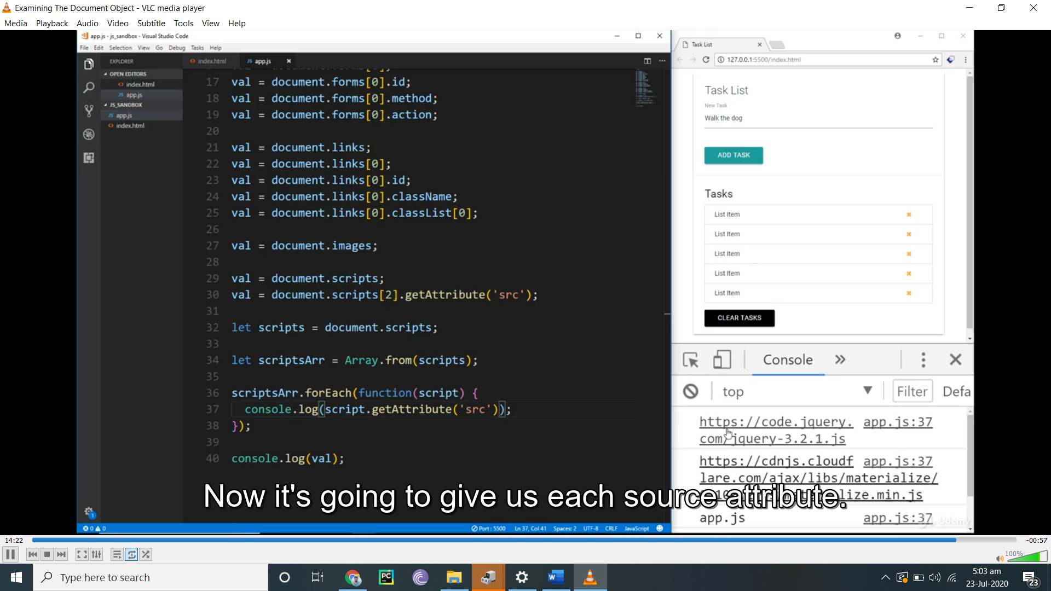

**For ech use only with array**

**Dom**

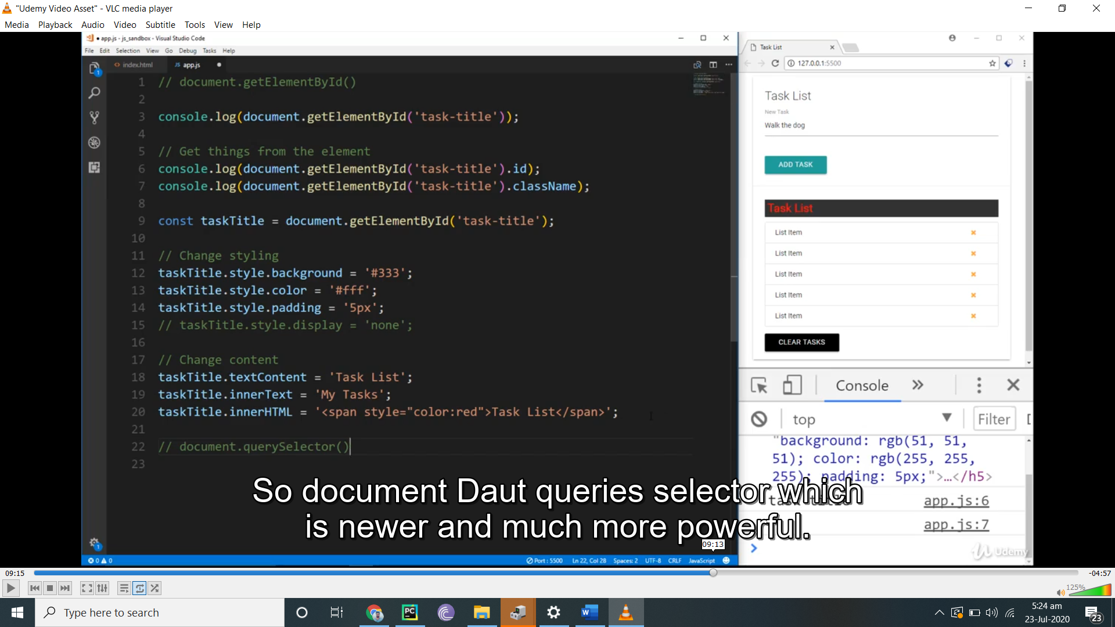

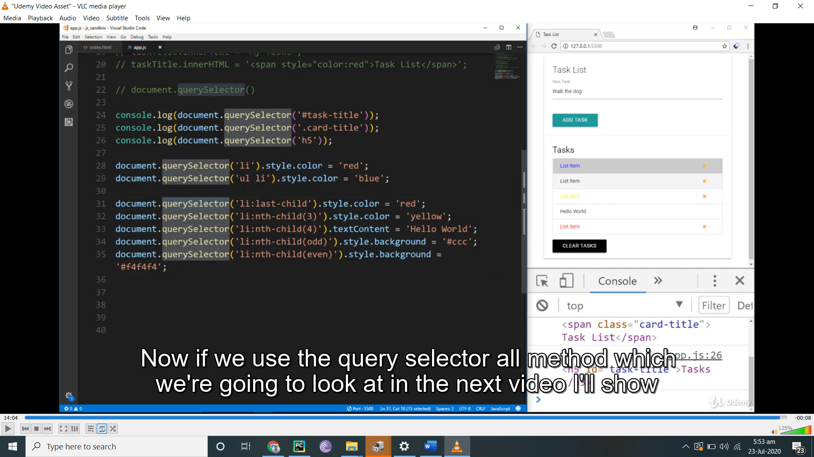

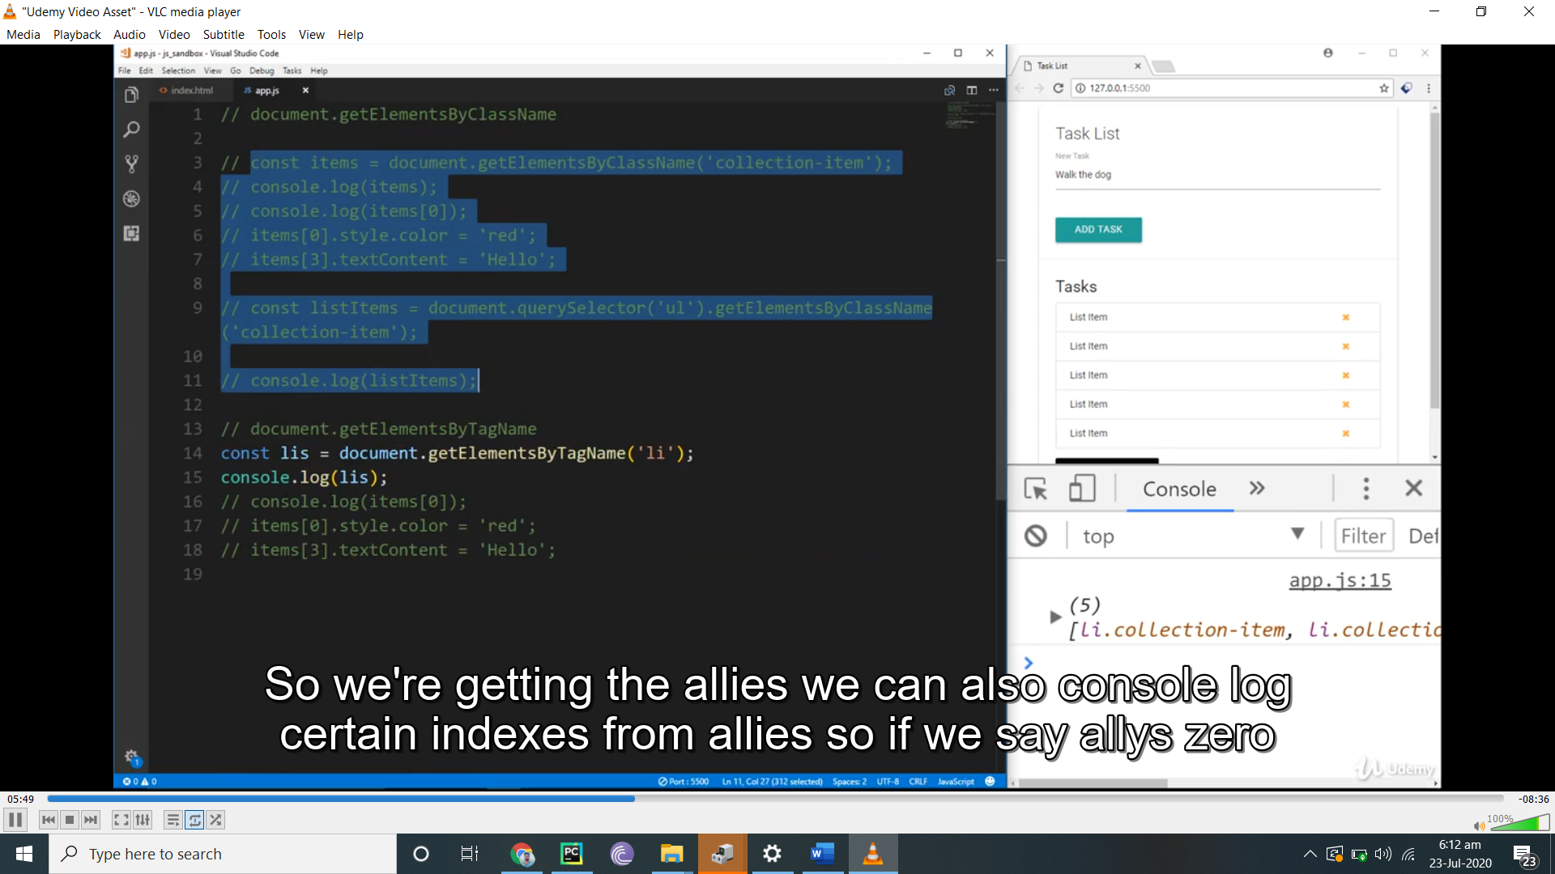

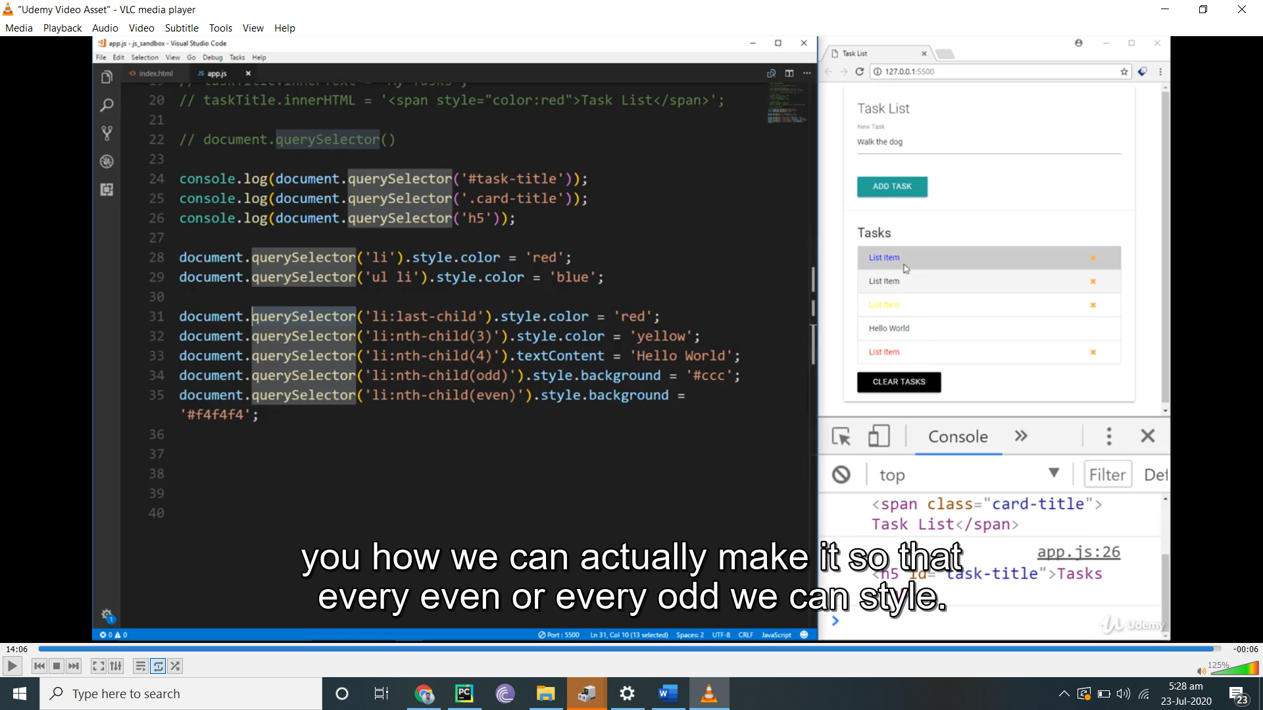

Its single line query means if u change all even so t will not only one even will be change

// document.getElementById()

// console.log(document.getElementById('task-title'));

// // Get things from the element

// console.log(document.getElementById('task-title').id);

// console.log(document.getElementById('task-title').className);

// const taskTitle = document.getElementById('task-title');

// // Change styling

// taskTitle.style.background = '#333';

// taskTitle.style.color = '#fff';

// taskTitle.style.padding = '5px';

// // taskTitle.style.display = 'none';

// // Change content

// taskTitle.textContent = 'Task List';

// taskTitle.innerText = 'My Tasks';

// taskTitle.innerHTML = '<span style="color:red">Task List</span>';

// document.querySelector()

console.log(document.querySelector('#task-title'));

console.log(document.querySelector('.card-title'));

console.log(document.querySelector('h5'));

document.querySelector('li').style.color = 'red';

document.querySelector('ul li').style.color = 'blue';

document.querySelector('li:last-child').style.color = 'red';

document.querySelector('li:nth-child(3)').style.color = 'yellow';

document.querySelector('li:nth-child(4)').textContent = 'Hello World';

document.querySelector('li:nth-child(odd)').style.background = '#ccc';

document.querySelector('li:nth-child(even)').style.background = '#f4f4f4';

dom multi query selector and foreach and for loop

// document.getElementsByClassName

// const items = document.getElementsByClassName('collection-item');

// console.log(items);

// console.log(items[0]);

// items[0].style.color = 'red';

// items[3].textContent = 'Hello';

// const listItems = document.querySelector('ul').getElementsByClassName('collection-item');

// console.log(listItems);

// document.getElementsByTagName

// let lis = document.getElementsByTagName('li');

// console.log(lis);

// console.log(lis[0]);

// lis[0].style.color = 'red';

// lis[3].textContent = 'Hello';

// // Conver HTML Collection into array

// lis = Array.from(lis);

// lis.reverse();

// lis.forEach(function(li, index){

//   console.log(li.className);

//   li.textContent = `${index}: Hello`;

// });

// console.log(lis);

// document.querySelectorAll

const items = document.querySelectorAll('ul.collection li.collection-item');

items.forEach(function(item, index){

    item.textContent = `${index}: Hello`;

});

const liOdd = document.querySelectorAll('li:nth-child(odd)');

const liEven = document.querySelectorAll('li:nth-child(even)');

liOdd.forEach(function(li, index){

  li.style.background = '#ccc';

});

for(let i = 0; i < liEven.length; i++){

  liEven[i].style.background = '#f4f4f4';

}

console.log(items);

transversing

let val;

const list = document.querySelector('ul.collection');

const listItem = document.querySelector('li.collection-item:first-child');

val = listItem;

val = list;

// Get child nodes

val = list.childNodes;

val = list.childNodes[0];

val = list.childNodes[0].nodeName;

val = list.childNodes[3].nodeType;

// 1 - Element

// 2 - Attribute (deprecated)

// 3 - Text node

// 8 - Comment

// 9 - Document itself

// 10 - Doctype

// Get children element nodes

val = list.children;

val = list.children[1];

list.children[1].textContent = 'Hello';

// Children of children

list.children[3].children[0].id = 'test-link';

val = list.children[3].children[0];

// First child

val = list.firstChild;

val = list.firstElementChild;

// Last child

val = list.lastChild;

val = list.lastElementChild;

// Count child elements

val = list.childElementCount;

// Get parent node

val = listItem.parentNode;

val = listItem.parentElement;

val = listItem.parentElement.parentElement;

// Get next sibling

val = listItem.nextSibling;

val = listItem.nextElementSibling.nextElementSibling.previousElementSibling;

// Get prev sibling

val = listItem.previousSibling;

val = listItem.previousElementSibling;

console.log(val);

create element

// Create element

const li  = document.createElement('li');

// Add class

li.className = 'collection-item';

// Add id

li.id = 'new-item';

// Add attribute

li.setAttribute('title', 'New Item');

// Create text node and append

li.appendChild(document.createTextNode('Hello World'));

// Create new link element

const link = document.createElement('a');

// Add classes

link.className = 'delete-item secondary-content';

// Add icon html

link.innerHTML = '<i class="fa fa-remove"></i>';

// Append link into li

li.appendChild(link);

// Append li as child to ul

document.querySelector('ul.collection').appendChild(li);

console.log(li);

removing elements

// REPLACE ELEMENT

// Create Element

const newHeading = document.createElement('h2');

// Add id

newHeading.id = 'task-title';

// New text node

newHeading.appendChild(document.createTextNode('Task List'));

// Get the old heading

const oldHeading = document.getElementById('task-title');

//Parent

const cardAction = document.querySelector('.card-action');

// Replace

cardAction.replaceChild(newHeading, oldHeading);

// REMOVE ELEMENT

const lis = document.querySelectorAll('li');

const list = document.querySelector('ul');

// Remove list item

lis[0].remove();

// Remove child element

list.removeChild(lis[3]);

// CLASSES & ATTR

const firstLi = document.querySelector('li:first-child');

const link = firstLi.children[0];

let val;

// Classes

val = link.className;

val = link.classList;

val = link.classList[0];

link.classList.add('test');

link.classList.remove('test');

val = link;

// Attributes

val = link.getAttribute('href');

val = link.setAttribute('href', 'http://google.com');

link.setAttribute('title', 'Google');

val = link.hasAttribute('title');

link.removeAttribute('title');

val = link;

console.log(val);

event listener

// document.querySelector('.clear-tasks').addEventListener('click', function(e){

//   console.log('Hello World');

//   //e.preventDefault();

// });

document.querySelector('.clear-tasks').addEventListener('click', onClick);

function onClick(e){

  //console.log('Clicked');

  let val;

  val = e;

  // Event target element

  val = e.target;

  val = e.target.id;

  val = e.target.className;

  val = e.target.classList;

  // Event type

  val = e.type;

  // Timestamp

  val = e.timeStamp;

  // Coords event relative to the window

  val = e.clientY;

  val = e.clientX;

  // Coords event relative to the element

  val = e.offsetY;

  val = e.offsetX;

  console.log(val);

}

Mouse event

const clearBtn = document.querySelector('.clear-tasks');

const card = document.querySelector('.card');

const heading = document.querySelector('h5');

// Click

// clearBtn.addEventListener('click', runEvent);

// Doubleclick

// clearBtn.addEventListener('dblclick', runEvent);

// Mousedown

// clearBtn.addEventListener('mousedown', runEvent);

// Mouseup

// clearBtn.addEventListener('mouseup', runEvent);

// Mouseenter

// card.addEventListener('mouseenter', runEvent);

// Mouseleave

// card.addEventListener('mouseleave', runEvent);

// Mouseover

// card.addEventListener('mouseover', runEvent);

// Mouseout

// card.addEventListener('mouseout', runEvent);

// Mousemove

card.addEventListener('mousemove', runEvent);

// Event Handler

function runEvent(e) {

  console.log(`EVENT TYPE: ${e.type}`);

  heading.textContent= `MouseX: ${e.offsetX} MouseY: ${e.offsetY}`;

  document.body.style.backgroundColor = `rgb(${e.offsetX}, ${e.offsetY}, 40)`;

}

Keyboard listenr

const form = document.querySelector('form');

const taskInput = document.getElementById('task');

const heading = document.querySelector('h5');

const select = document.querySelector('select');

// Clear input

taskInput.value = '';

// form.addEventListener('submit', runEvent);

// Keydown

//taskInput.addEventListener('keydown', runEvent);

// Keydown

// taskInput.addEventListener('keyup', runEvent);

// Keypress

// taskInput.addEventListener('keypress', runEvent);

// Focus

// taskInput.addEventListener('focus', runEvent);

// Blur

// taskInput.addEventListener('blur', runEvent);

// Cut

// taskInput.addEventListener('cut', runEvent);

// Paste

// taskInput.addEventListener('paste', runEvent);

// Input

// taskInput.addEventListener('input', runEvent);

// Change

select.addEventListener('change', runEvent);

function runEvent(e){

  console.log(`EVENT TYPE: ${e.type}`);

  //console.log(e.target.value);

  // heading.innerText = e.target.value;

  // Get input value

  // console.log(taskInput.value);

  // e.preventDefault();

}

Event bubling and delegtion

// EVENT BUBBLING

// document.querySelector('.card-title').addEventListener('click', function(){

//   console.log('card title');

// });

// document.querySelector('.card-content').addEventListener('click', function(){

//   console.log('card content');

// });

// document.querySelector('.card').addEventListener('click', function(){

//   console.log('card');

// });

// document.querySelector('.col').addEventListener('click', function(){

//   console.log('col');

// });

// EVENT DELGATION

// const delItem = document.querySelector('.delete-item');

// delItem.addEventListener('click', deleteItem);

document.body.addEventListener('click', deleteItem);

function deleteItem(e){

  // if(e.target.parentElement.className === 'delete-item secondary-content'){

  //   console.log('delete item');

  // }

  if(e.target.parentElement.classList.contains('delete-item')){

    console.log('delete item');

    e.target.parentElement.parentElement.remove();

  }

}

// set local storage item

// localStorage.setItem('name', 'John');

// localStorage.setItem('age', '30');

// set session storage item

// sessionStorage.setItem('name', 'Beth');

// remove from storage

// localStorage.removeItem('name');

// get from storage

// const name = localStorage.getItem('name');

// const age = localStorage.getItem('age');

// // clear local storage

// localStorage.clear();

// console.log(name, age);

document.querySelector('form').addEventListener('submit', function(e){

  const task = document.getElementById('task').value;

  let tasks;

  if(localStorage.getItem('tasks') === null) {

    tasks = [];

  } else {

    tasks = JSON.parse(localStorage.getItem('tasks'));

  }

  tasks.push(task);

  localStorage.setItem('tasks', JSON.stringify(tasks));

  alert('Task saved');

  e.preventDefault();

});

const tasks = JSON.parse(localStorage.getItem('tasks'));

tasks.forEach(function(task){

  console.log(task);

});

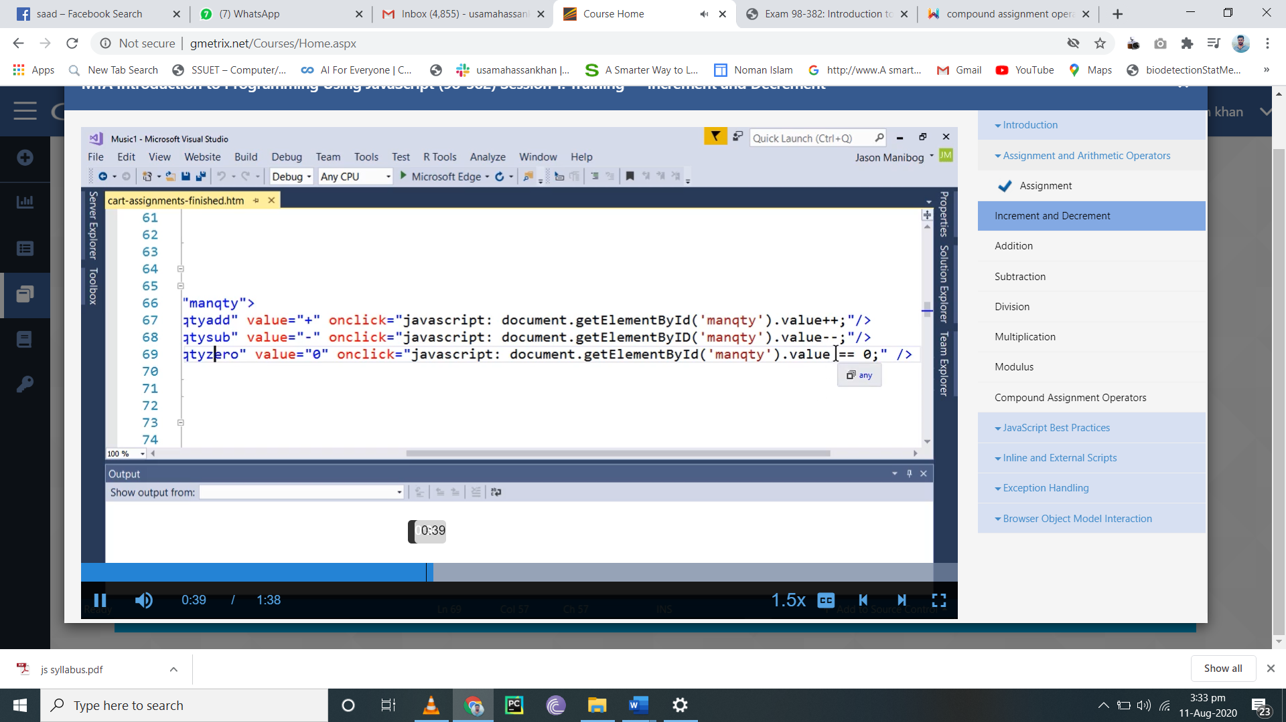

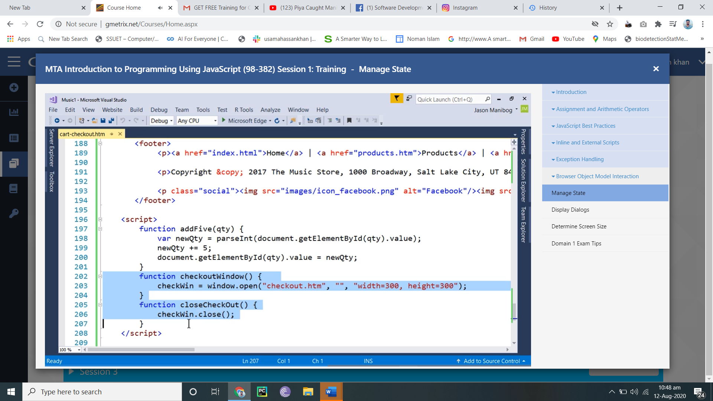

Two possible states in js

Open and invisible

Debugger stop the code

Break point t puse the code

Camcle cast

Ist word small and every ist elemnt after ist word capital

Comment us efor explain code and ignore bad code

Dom type is object

Strict use so we can not use uninatialize variable

Shitt is opposite if pop it dldt from first

Unshift is opposite of push it add ist of array

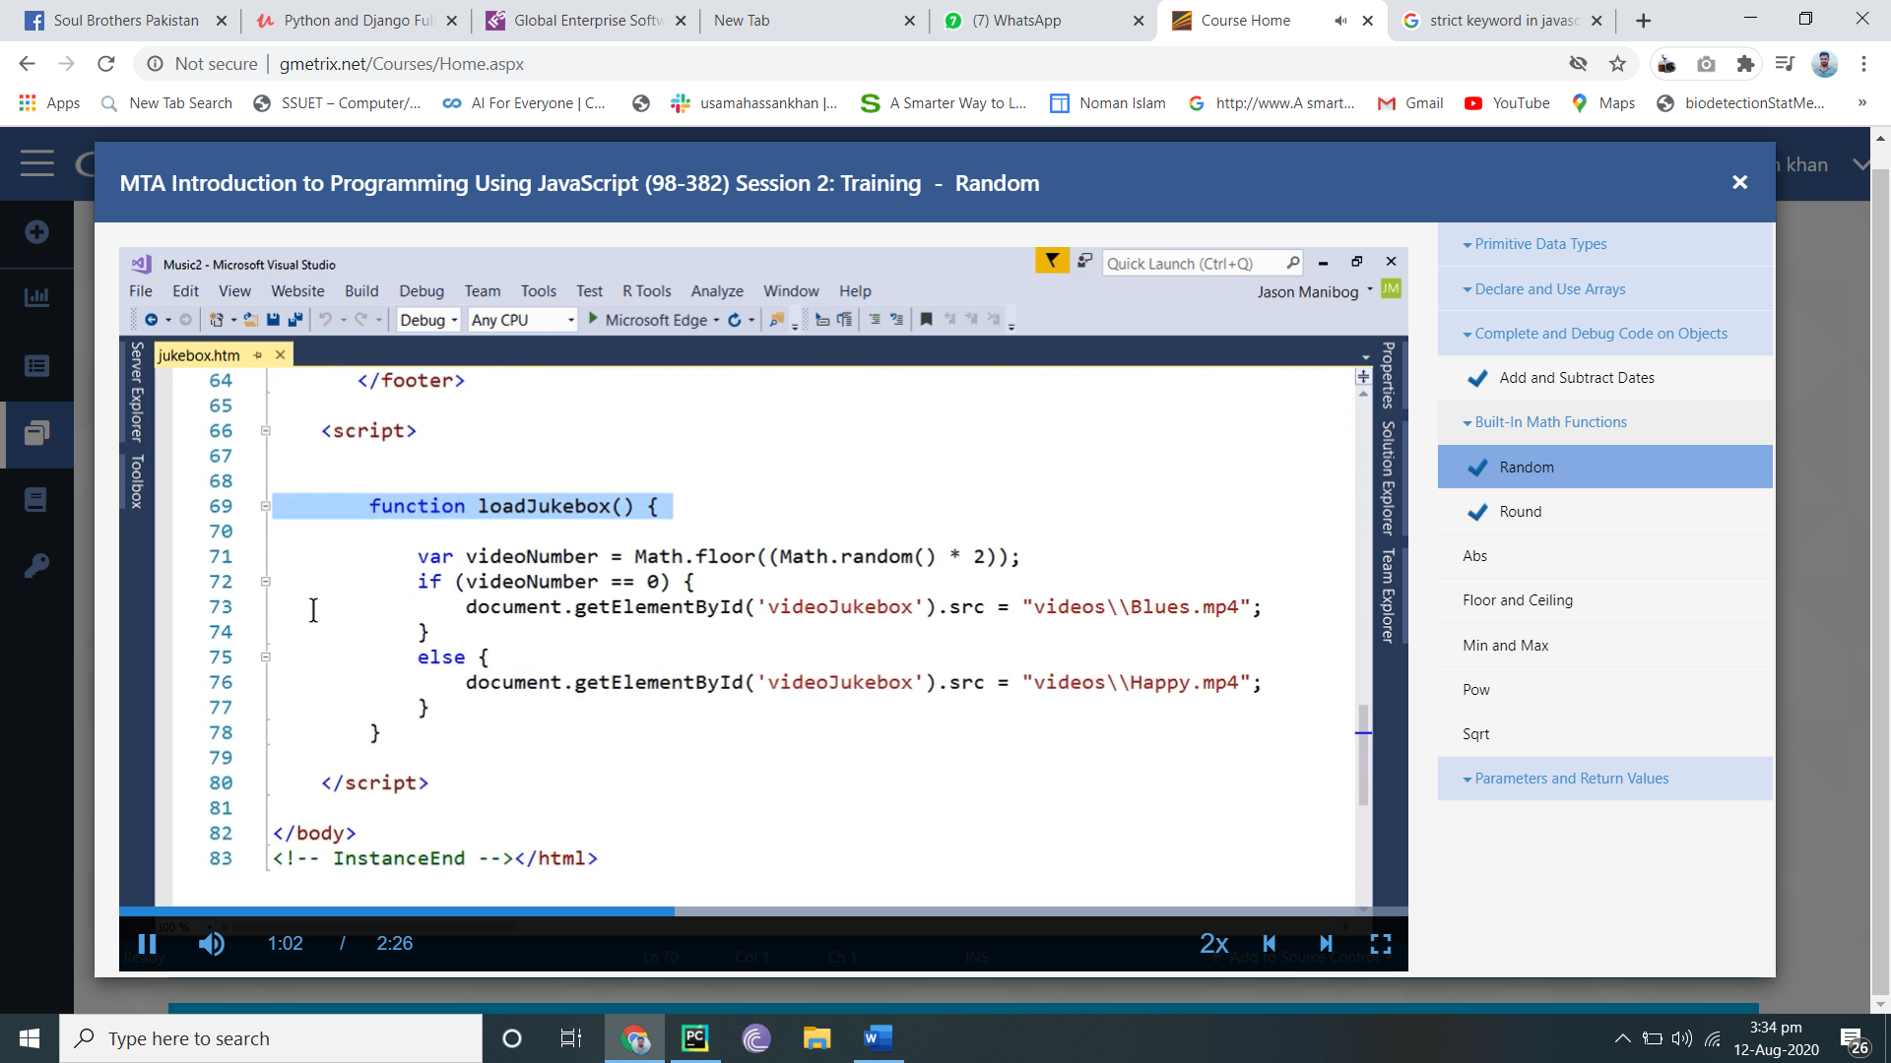

Global varibl show when write in console unlike local

Var star wit var and inside fun is local variable it whow undefned in console

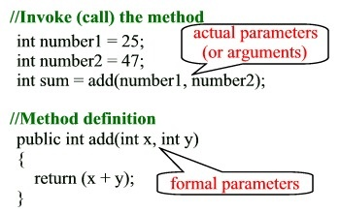

Do lllop run at least one

While nt run when contion fasleo

Do loop,

**Do{ scjkkp;}**

**While();**

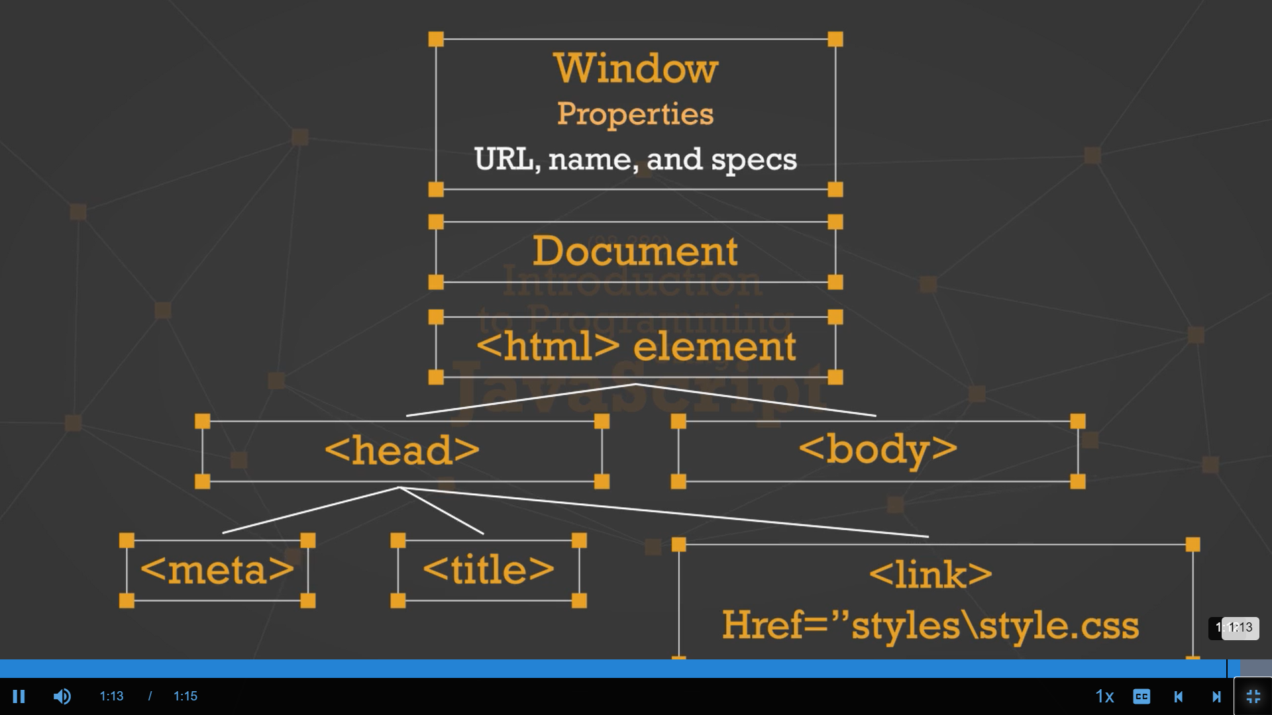

**Window has name specs and url**

**Width hight spcess url is path name is status=no**

Addiion

       <div class="order_buttons">

        <p><input type="button" class="buttons" value="Update Cart"

                  onclick="javascript: document.getElementById('subtotal').innerHTML

= parseFloat(document.getElementById('mantotal').innerHTML)

+ parseFloat(document.getElementById('drumtotal').innerHTML)

+ parseFloat(document.getElementById('tromtotal').innerHTML);" /></p>

        <p><input type="button" class="buttons" value="Checkout"></p>

    </div>

Increment and drecrement

|  |
| --- |
| <input type="text" value="1" id="manqty"> <br/> |
|  | <button id="manqtyadd" onclick="javascript: document.getElementById('manqty').value++;">+</button> |
|  | <button id="manqtysubtract" onclick="javascript: document.getElementById('manqty').value--;">-</button> |
|  | <button id="manqtyzero" onclick="javascript: document.getElementById('manqty').value = 0;">Clear</button> |
|  | <button id="manqtyfive" onclick="addFive(manqty);">Add Five</button> |

 <button id="manqtyfive" onclick="addFive('manqty');">Add Five</button>

    <script>

        function addFive(qty) {

            var newQty = parseInt(document.getElementById(qty).value);

            newQty += 5;

            document.getElementById(qty).value = newQty;

        }

Window has 4 aurgumebt

|  |
| --- |
| function checkoutWindow() { |
|  | checkWin = window.open("checkout.htm", "", "width=300, height=300"); |
|  | } |
|  | function closeCheckOut() { |
|  | checkWin.close(); |
|  | } |

url,specs,name

|  |
| --- |
| function welcome() { |
|  | yourName = prompt("Enter your name"); |
|  | if (confirm("Is your name correct?") == true) |
|  | { |
|  | alert("Welcome, " + yourName); |
|  | } |

<body onload="alert('This screen is ' + screen.width +' pixels wide and ' + screen.height + ' pixels high')";>

|  |
| --- |
| function loadJukebox() { |
|  |  |
|  | var videoNumber = Math.floor((Math.random() * 2)); |
|  | if (videoNumber == 0) { |
|  | document.getElementById('videoJukebox').src = "videos\\Blues.mp4"; |
|  | } |
|  | else { |
|  | document.getElementById('videoJukebox').src = "videos\\Happy.mp4"; |
|  | } |
|  | } |

Date

|  |
| --- |
| function lessonSchedule() { |
|  | var lessonStartDate = new Date('October 2, 2017 06:00:00 PM'); |
|  | var lessonEndDate = new Date(lessonStartDate); |
|  | var detailsSchedule = document.getElementById('lessonSchedule') |
|  | lessonEndDate.setDate(lessonEndDate.getDate() + 56); |
|  | var breakDate = new Date('November 20, 2017 12:00:00 AM'); |
|  |  |
|  | detailsSchedule.innerHTML += "<br /> First lesson: " |
|  | + lessonStartDate.toLocaleDateString() + "<br />Subsequent lessons: "; |
|  |  |

Strict key word

|  |
| --- |
| function getPracticeHours() { |
|  | "use strict"; |
|  | try |
|  | { |
|  | var hoursEntered = parseInt(document.getElementById('practiceHours').value) |
|  |  |
|  | document.getElementById('practiceWeeks').innerHTML = |
|  | 'It will take you ' + 20 / hoursEntered + ' weeks to finish this program at ' |
|  | + hoursEntered + ' hours per week.'; |
|  | } |
|  | catch(error) |
|  | { |
|  | alert("Error: " + error.description); |
|  | } |
|  | } |

Checkbox

|  |
| --- |
|  |
| if (document.getElementById('wedgeMute').checked && document.getElementById('pappsMute').checked) { |
|  | document.getElementById('tuningList').innerHTML = "You selected both mutes."; |
|  | } |
|  | else { |
|  | document.getElementById('tuningList').innerHTML = ""; |
|  | } |
|  |  |

Aray

|  |
| --- |
| tuningList = ["Tuning Lever", "Tuning Fork"]; |
|  | fieldTotals = []; |
|  | function updateList() { |
|  | document.getElementById('tuningList').innerHTML = "<ul>"; |
|  |  |
|  | for (var i = 0; i < tuningList.length; i++) { |
|  | document.getElementById('tuningList').innerHTML += |
|  | "<li>" + tuningList[i] + "</li>" |
|  | } |

Todolist

const form = document.querySelector('#task-form');

const taskList = document.querySelector('.collection');

const clearBtn = document.querySelector('.clear-tasks');

const filter = document.querySelector('#filter');

const taskInput = document.querySelector('#task');

// Load all event listeners

loadEventListeners();

// Load all event listeners

function loadEventListeners() {

  // Add task event

  form.addEventListener('submit', addTask);

  // Remove task event

  taskList.addEventListener('click', removeTask);

  // Clear task event

  clearBtn.addEventListener('click', clearTasks);

  // Filter tasks event

  filter.addEventListener('keyup', filterTasks);

}

// Add Task

function addTask(e) {

  if(taskInput.value === '') {

    alert('Add a task');

  }

  // Create li element

  const li = document.createElement('li');

  // Add class

  li.className = 'collection-item';

  // Create text node and append to li

  li.appendChild(document.createTextNode(taskInput.value));

  // Create new link element

  const link = document.createElement('a');

  // Add class

  link.className = 'delete-item secondary-content';

  // Add icon html

  link.innerHTML = '<i class="fa fa-remove"></i>';

  // Append the link to li

  li.appendChild(link);

  // Append li to ul

  taskList.appendChild(li);

  // Clear input

  taskInput.value = '';

  e.preventDefault();

}

// Remove Task

function removeTask(e) {

  if(e.target.parentElement.classList.contains('delete-item')) {

    if(confirm('Are You Sure?')) {

      e.target.parentElement.parentElement.remove();

    }

  }

}

// Clear Tasks

function clearTasks() {

  // taskList.innerHTML = '';

  // Faster

  while(taskList.firstChild) {

    taskList.removeChild(taskList.firstChild);

  }

  // https://jsperf.com/innerhtml-vs-removechild

}

// Filter Tasks

function filterTasks(e) {

  const text = e.target.value.toLowerCase();

  document.querySelectorAll('.collection-item').forEach(function(task){

    const item = task.firstChild.textContent;

    if(item.toLowerCase().indexOf(text) != -1){

      task.style.display = 'block';

    } else {

      task.style.display = 'none';

    }

  });

}

 <div class="container">

    <div class="row">

      <div class="col s12">

        <div id="main" class="card">

          <div class="card-content">

            <span class="card-title">Task List</span>

            <div class="row">

              <form id="task-form">

                <div class="input-field col s12">

                  <input type="text" name="task" id="task">

                  <label for="task">New Task</label>

                </div>

                <input type="submit" value="Add Task" class="btn">

              </form>

            </div>

          </div>

          <div class="card-action">

            <h5 id="task-title">Tasks</h5>

            <div class="input-field col s12">

              <input type="text" name="filter" id="filter">

              <label for="filter">Filter Tasks</label>

            </div>

            <ul class="collection"></ul>

            <a href="#" class="clear-tasks btn black">Clear Tasks</a>

          </div>

        </div>

      </div>

    </div>

  </div>

Guess numb]

let min = 1,

    max = 10,

    winningNum = 2,

    guessesLeft = 3;

// UI Elements

const game = document.querySelector('#game'),

      minNum = document.querySelector('.min-num'),

      maxNum = document.querySelector('.max-num'),

      guessBtn = document.querySelector('#guess-btn'),

      guessInput = document.querySelector('#guess-input'),

      message = document.querySelector('.message');

// Assign UI min and max

minNum.textContent = min;

maxNum.textContent = max;

// Listen for guess

guessBtn.addEventListener('click', function(){

  let guess = parseInt(guessInput.value);

  // Validate

  if(isNaN(guess) || guess < min || guess > max){

    setMessage(`Please enter a number between ${min} and ${max}`, 'red');

  }

  // Check if won

  if(guess === winningNum){

    // Disable input

    guessInput.disabled = true;

    // Change border color

    guessInput.style.borderColor = 'green';

    // Set message

    setMessage(`${winningNum} is correct, YOU WIN!`, 'green');

  } else {

  }

});

// Set message

function setMessage(msg, color){

  message.style.color = color;

  message.textContent = msg;

}

 <script>

        function a(name,age){

            this.name=name;

            this.age=age;

        }

        const b=new a("usama",15);

        console.log(b);

        document.write(b.name);

document.write(b.age);

    </script>

If u are using this keywor as gloaal so it invoke window object

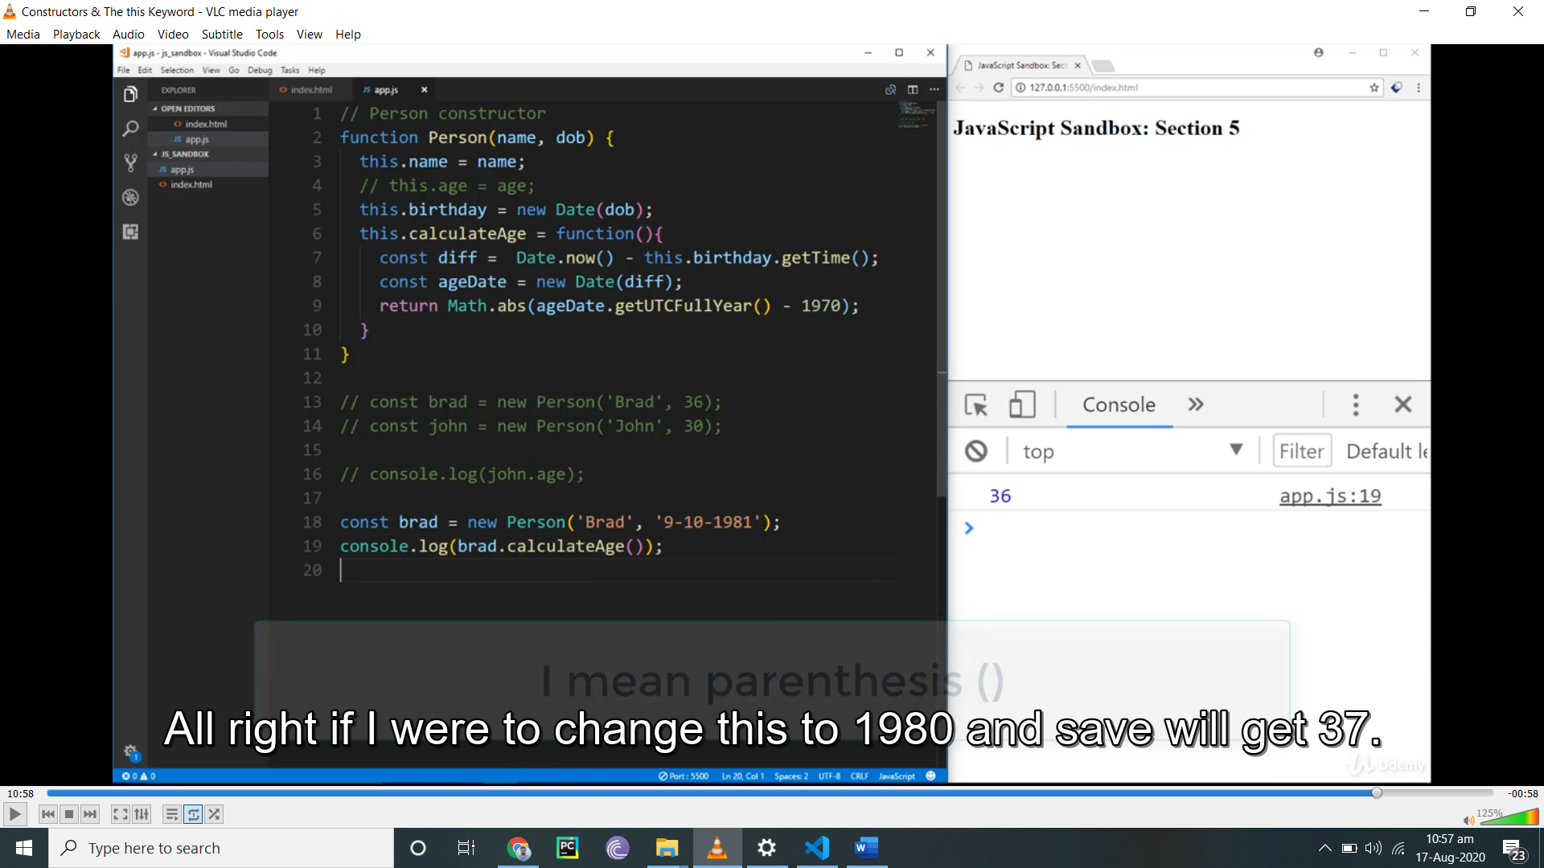

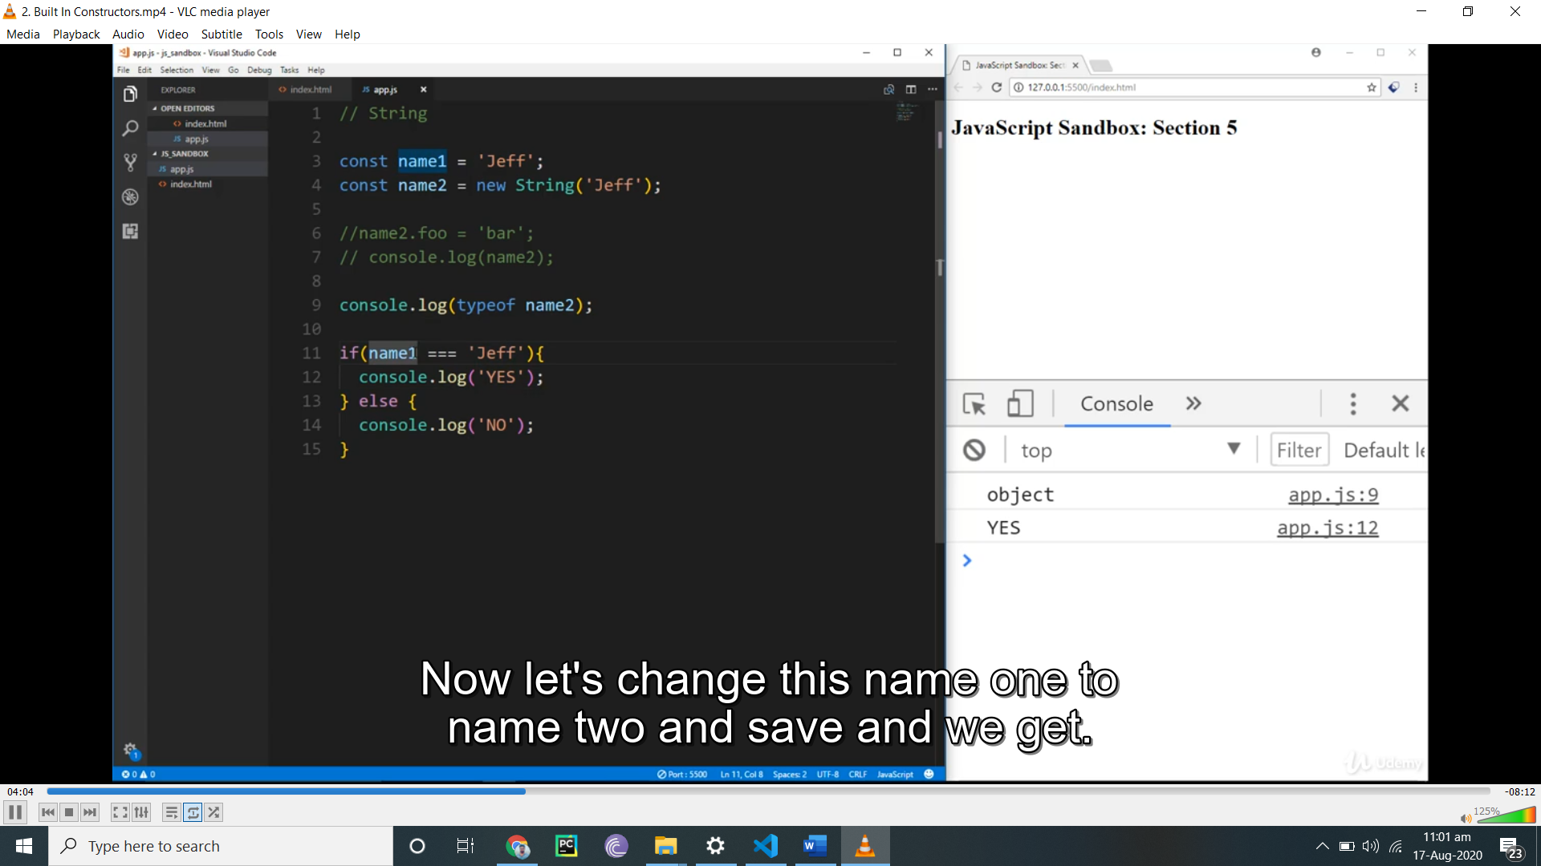

Name 1 is string and name 2 is object

Name2==”jeff” is false

Name 1==”jeff”

True bcs string

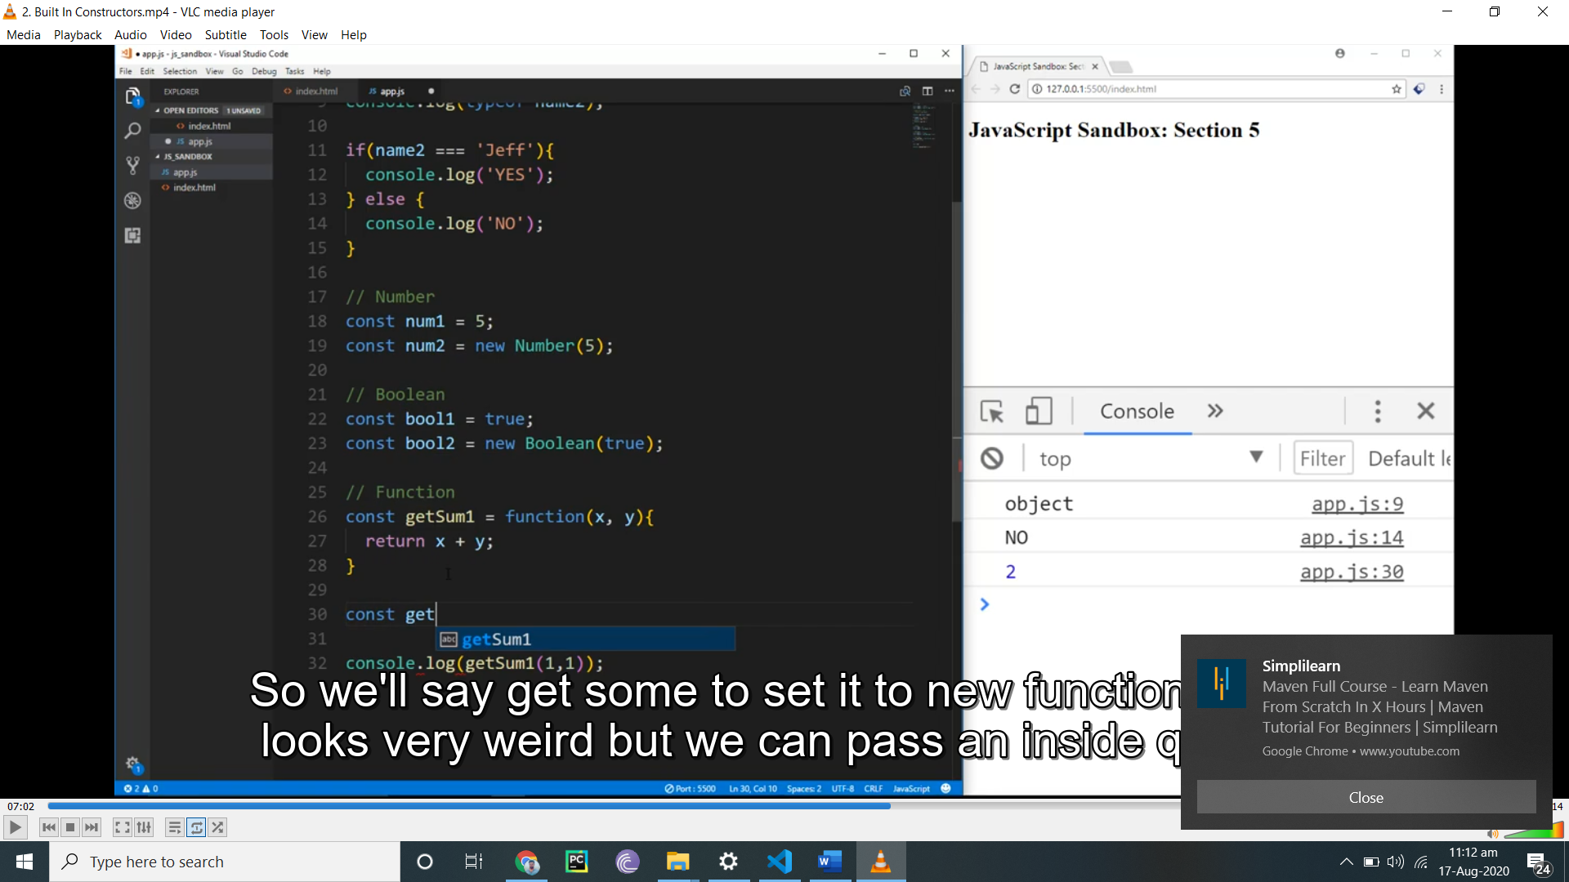

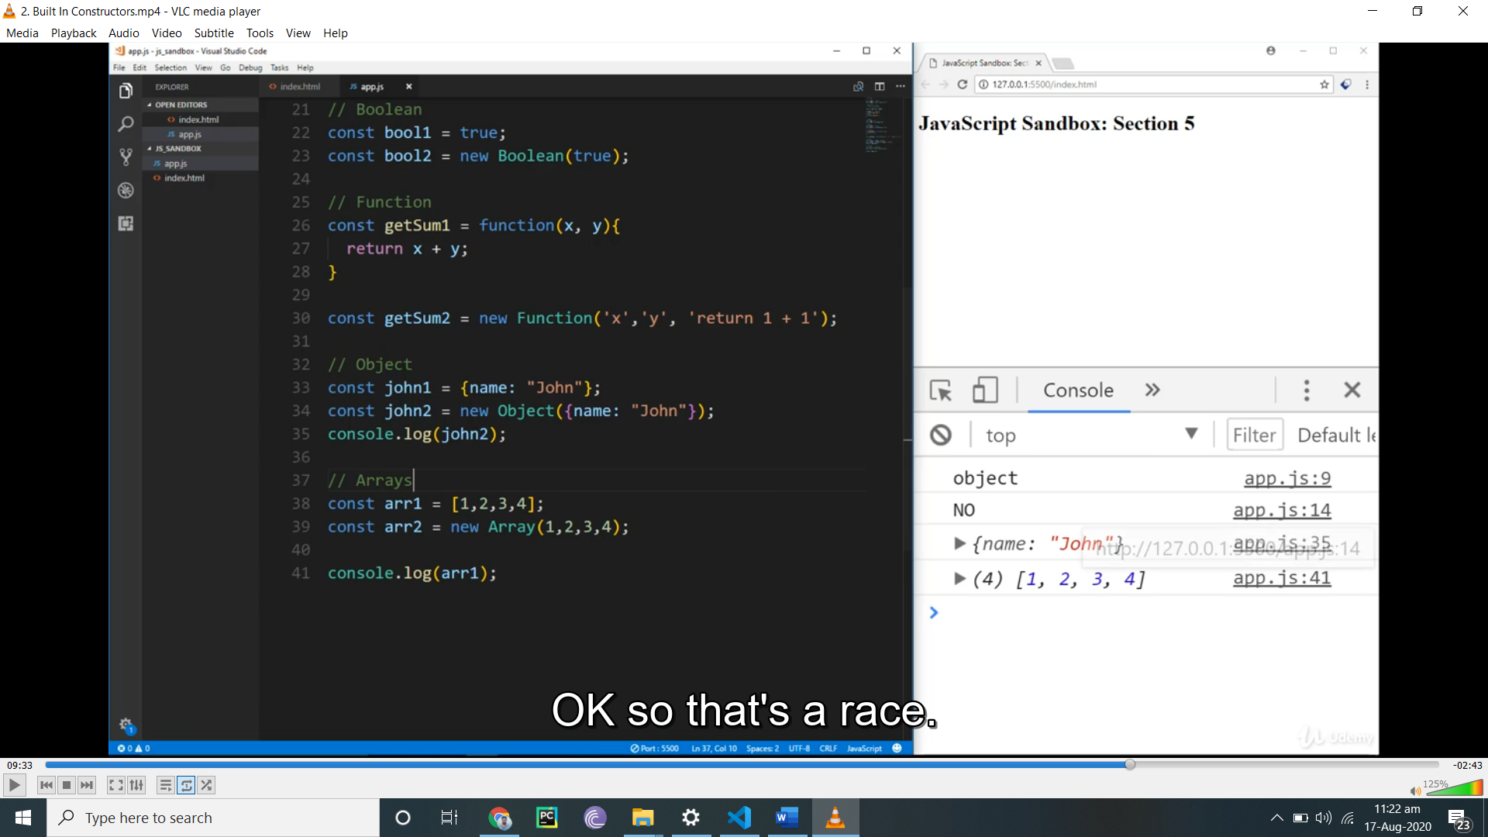

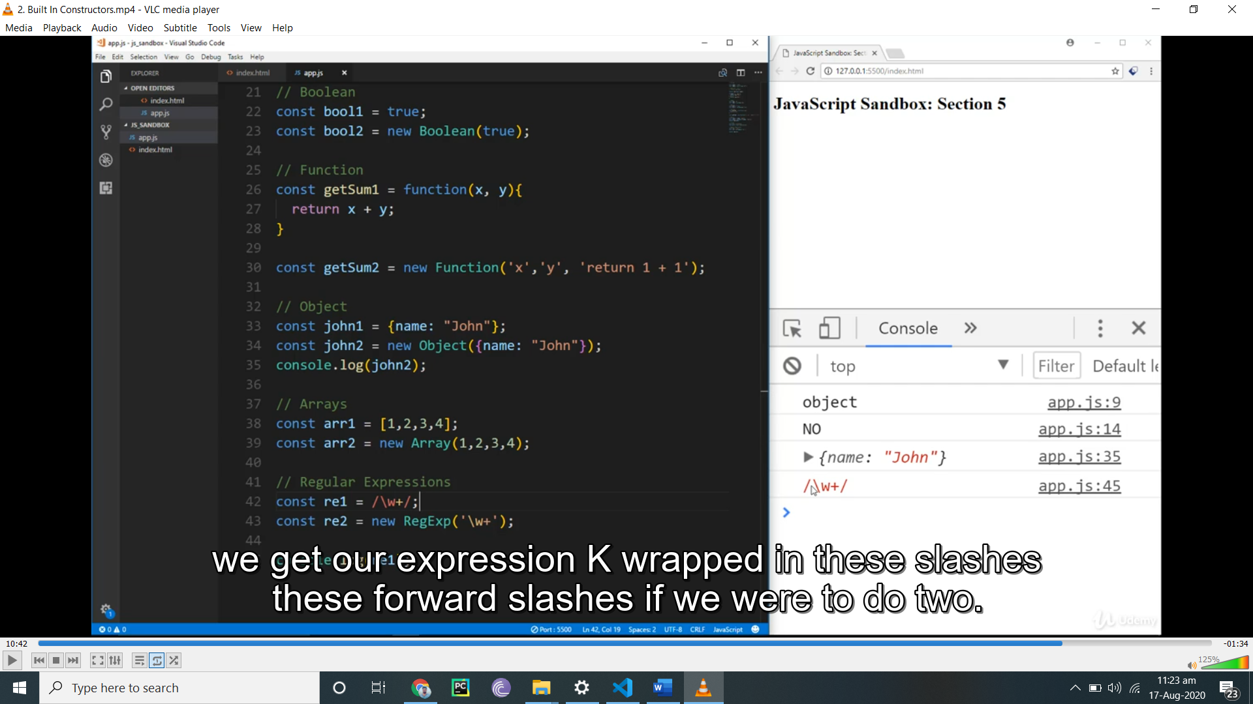

Prototype

//Object.prototype

//Person.prototype

// Person constructor

function Person(firstName, lastName, dob) {

  this.firstName = firstName;

  this.lastName = lastName;

  this.birthday = new Date(dob);

  // this.calculateAge = function(){

  //   const diff =  Date.now() - this.birthday.getTime();

  //   const ageDate = new Date(diff);

  //   return Math.abs(ageDate.getUTCFullYear() - 1970);

  // }

}

// Calculate age

Person.prototype.calculateAge = function(){

  const diff =  Date.now() - this.birthday.getTime();

  const ageDate = new Date(diff);

  return Math.abs(ageDate.getUTCFullYear() - 1970);

}

// Get full name

Person.prototype.getFullName = function(){

  return `${this.firstName} ${this.lastName}`;

}

// Gets Married

Person.prototype.getsMaried = function(newLastName){

  this.lastName = newLastName;

}

const john = new Person('John', 'Doe', '8-12-90');

const mary = new Person('Mary', 'Johnson', 'March 20 1978');

console.log(mary);

console.log(john.calculateAge());

console.log(mary.getFullName());

mary.getsMaried('Smith');

console.log(mary.getFullName());

console.log(mary.hasOwnProperty('firstName')); this returns true becs its obejct

console.log(mary.hasOwnProperty('getFullName')); this returns false bcs its prototypr

if not use prototypr it will return bject not output,its used out side of function

manipulates as well

thes ear enot stored in object

inheritance

// Person constructor

function Person(firstName, lastName) {

  this.firstName = firstName;

  this.lastName = lastName;

}

// Greeting

Person.prototype.greeting = function(){

  return `Hello there ${this.firstName} ${this.lastName}`;

}

const person1 = new Person('John', 'Doe');

console.log(person1.greeting());

// Customer constructor

function Customer(firstName, lastName, phone, membership) {

  Person.call(this, firstName, lastName);

  this.phone = phone;

  this.membership = membership;

}

// Inherit the Person prototype methods

Customer.prototype = Object.create(Person.prototype);

// Make customer.prototype return Customer()

Customer.prototype.constructor = Customer;

// Create customer

const customer1 = new Customer('Tom', 'Smith', '555-555-5555', 'Standard');

console.log(customer1);

// Customer greeting

Customer.prototype.greeting = function(){

  return `Hello there ${this.firstName} ${this.lastName} welcome to our company`;

}

console.log(customer1.greeting());

how to create object

const personPrototypes = {

  greeting: function() {

    return `Hello there ${this.firstName} ${this.lastName}`;

  },

  getsMarried: function(newLastName) {

    this.lastName = newLastName;

  }

}

const mary = Object.create(personPrototypes);

mary.firstName = 'Mary';

mary.lastName = 'Williams';

mary.age = 30;

mary.getsMarried('Thompson');

console.log(mary.greeting());

const brad = Object.create(personPrototypes, {

  firstName: {value: 'Brad'},

  lastName: {value: 'Traversy'},

  age: {value: 36}

});

console.log(brad);

console.log(brad.greeting());

how to use class in es6

every method use inside class is prototype

use static with class not object

class Person {

  constructor(firstName, lastName, dob) {

    this.firstName = firstName;

    this.lastName = lastName;

    this.birthday = new Date(dob);

  }

  greeting() {

    return `Hello there ${this.firstName} ${this.lastName}`;

  }

  calculateAge() {

    const diff = Date.now() - this.birthday.getTime();

    const ageDate = new Date(diff);

    return Math.abs(ageDate.getUTCFullYear() - 1970);

  }

  getsMarried(newLastName) {

    this.lastName = newLastName;

  }

  static addNumbers(x, y) {

    return x + y;

  }

}

const mary = new Person('Mary', 'Williams', '11-13-1980');

mary.getsMarried('Thompson');

console.log(mary);

console.log(Person.addNumbers(1,2));

inheritance in es 6 we did inheritance in es5 befor enow doing inherita with es6

class Person {

  constructor(firstName, lastName) {

    this.firstName = firstName;

    this.lastName = lastName;

  }

  greeting() {

    return `Hello there ${this.firstName} ${this.lastName}`;

  }

}

class Customer extends Person {

  constructor(firstName, lastName, phone, membership) {

    super(firstName, lastName);

    this.phone = phone;

    this.membership = membership;

  }

  static getMembershipCost() {

    return 500;

  }

}

const john = new Customer('John', 'Doe', '555-555-5555', 'Standard');

console.log(john.greeting());

console.log(Customer.getMembershipCost());

synchronous and asychrons code

schronos with for load then run next function

asychronos not

all librarys datacomes likes a sychinrns

ajax node js

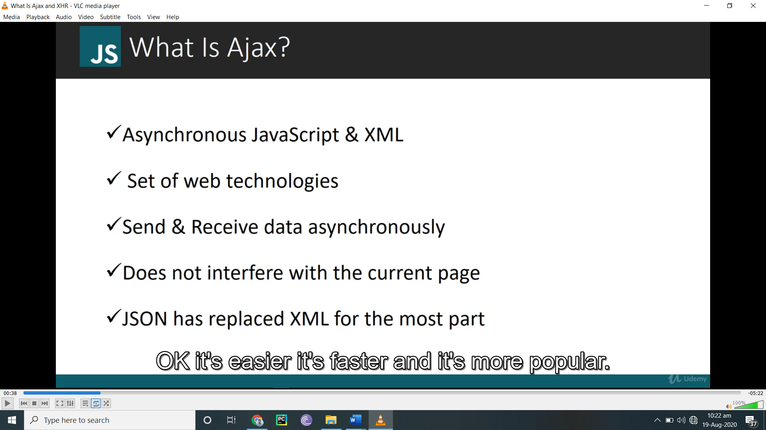

Json replaces axajs

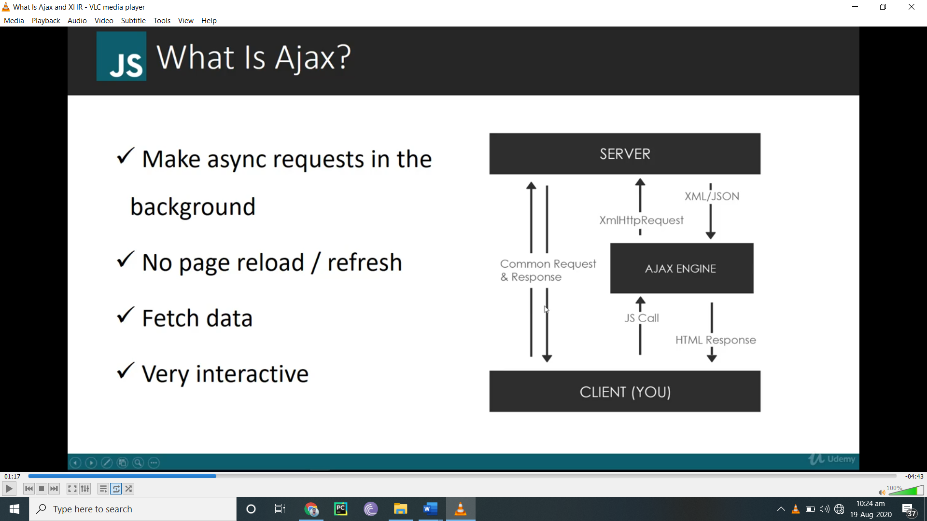

Ajax code

document.getElementById('button').addEventListener('click', loadData);

function loadData() {

  // Create an XHR Object

  const xhr = new XMLHttpRequest();

  // OPEN

  xhr.open('GET', 'data.txt', true);

  // console.log('READYSTATE', xhr.readyState);

  // Optional - Used for spinners/loaders

  xhr.onprogress = function(){

    console.log('READYSTATE', xhr.readyState);

  }

  xhr.onload = function(){

    console.log('READYSTATE', xhr.readyState);

    if(this.status === 200) {

      // console.log(this.responseText);

      document.getElementById('output').innerHTML = `<h1>${this.responseText}</h1>`;

    }

  }

  // xhr.onreadystatechange = function() {

  //   console.log('READYSTATE', xhr.readyState);

  //   if(this.status === 200 && this.readyState === 4){

  //     console.log(this.responseText);

  //   }

  // }

  xhr.onerror = function() {

    console.log('Request error...');

  }

  xhr.send();

    // readyState Values

    // 0: request not initialized

    // 1: server connection established

    // 2: request received

    // 3: processing request

    // 4: request finished and response is ready

  // HTTP Statuses

  // 200: "OK"

  // 403: "Forbidden"

  // 404: "Not Found"

}

Now json data fetch without or with array

document.getElementById('button1').addEventListener('click', loadCustomer);

document.getElementById('button2').addEventListener('click', loadCustomers);

// Load Single Customer

function loadCustomer(e) {

  const xhr = new XMLHttpRequest();

  xhr.open('GET', 'customer.json', true);

  xhr.onload = function(){

    if(this.status === 200) {

      // console.log(this.responseText);

      const customer = JSON.parse(this.responseText);

      const output = `

        <ul>

          <li>ID: ${customer.id}</li>

          <li>Name: ${customer.name}</li>

          <li>Company: ${customer.company}</li>

          <li>Phone: ${customer.phone}</li>

        </ul>

      `;

      document.getElementById('customer').innerHTML = output;

    }

  }

  xhr.send();

}

With array

// Load Customers

here data is in array like

[{

  "A":1

}

{"b":3}

]

function loadCustomers(e) {

  const xhr = new XMLHttpRequest();

  xhr.open('GET', 'customers.json', true);

  xhr.onload = function(){

    if(this.status === 200) {

      // console.log(this.responseText);

      const customers = JSON.parse(this.responseText);

      let output = '';

      customers.forEach(function(customer){

        output += `

        <ul>

          <li>ID: ${customer.id}</li>

          <li>Name: ${customer.name}</li>

          <li>Company: ${customer.company}</li>

          <li>Phone: ${customer.phone}</li>

        </ul>

      `;

      });

      document.getElementById('customers').innerHTML = output;

    }

  }

  xhr.send();

}

External api

document.querySelector('.get-jokes').addEventListener('click', getJokes);

function getJokes(e) {

  const number = document.querySelector('input[type="number"]').value;

  const xhr = new XMLHttpRequest();

  xhr.open('GET', `http://api.icndb.com/jokes/random/${number}`, true);

  xhr.onload = function() {

    if(this.status === 200) {

      const response = JSON.parse(this.responseText);

      let output = '';

      if(response.type === 'success') {

        response.value.forEach(function(joke){

          output += `<li>${joke.joke}</li>`;

        });

      } else {

        output += '<li>Something went wrong</li>';

      }

      document.querySelector('.jokes').innerHTML = output;

    }

  }

  xhr.send();

  e.preventDefault();

}

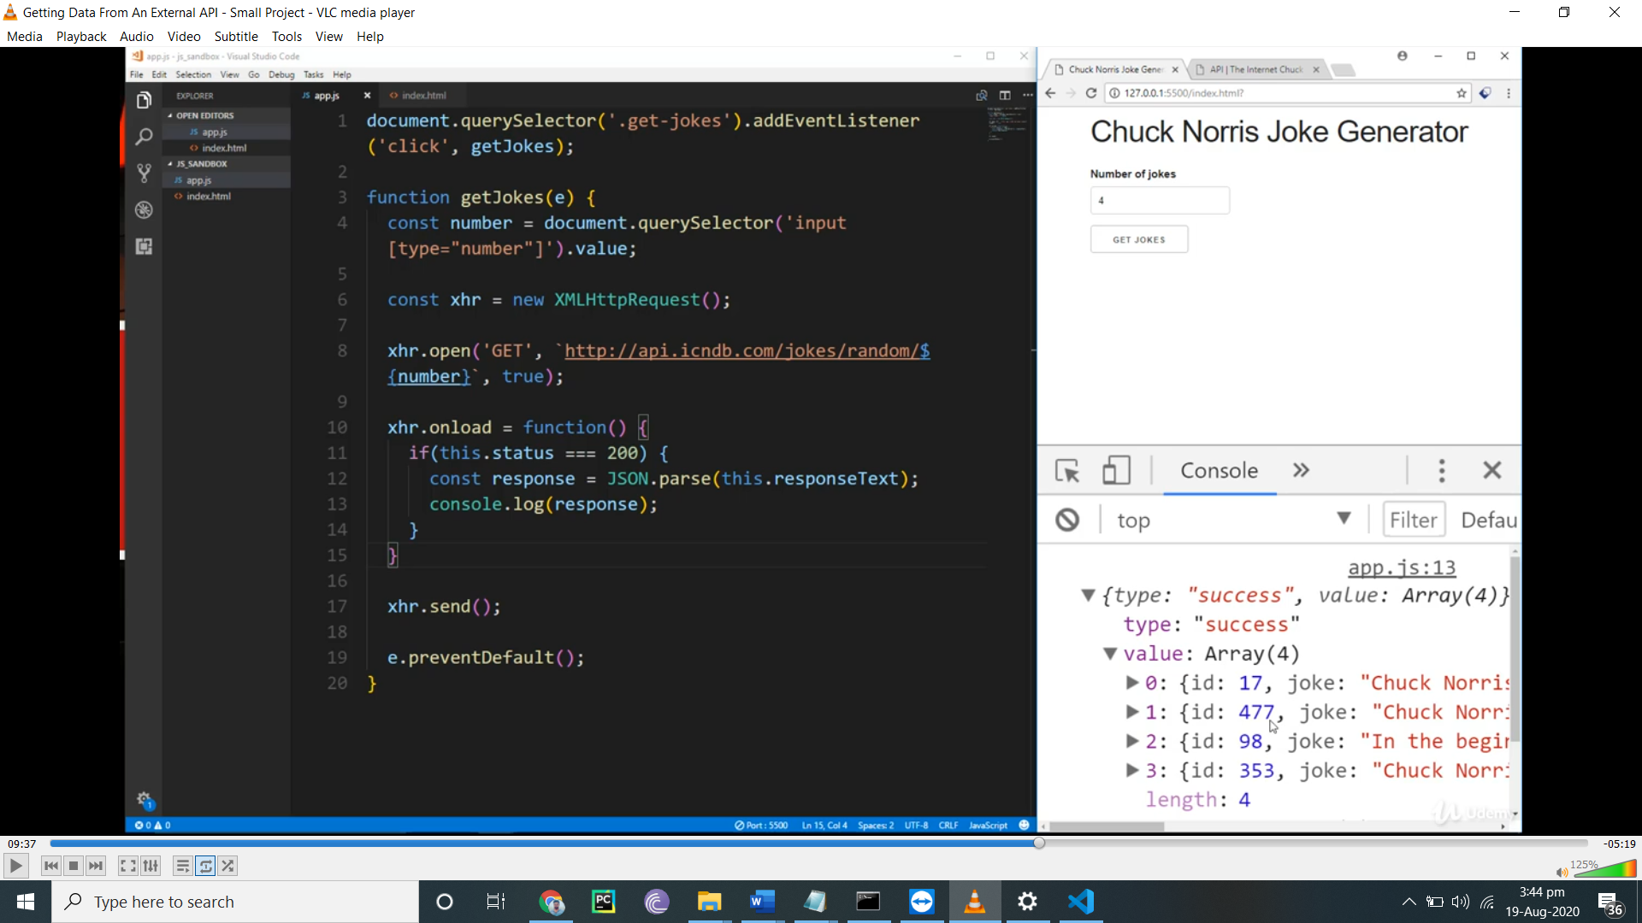

Fetch api

document.getElementById('button1').addEventListener('click', getText);

document.getElementById('button2').addEventListener('click', getJson);

document.getElementById('button3').addEventListener('click', getExternal);

// Get local text file data

function getText() {

  fetch('test.txt')

    .then(function(res){

      return res.text();

    })

    .then(function(data) {

      console.log(data);

      document.getElementById('output').innerHTML = data;

    })

    .catch(function(err){

      console.log(err);

    });

}

// Get local json data

function getJson() {

  fetch('posts.json')

    .then(function(res){

      return res.json();

    })

    .then(function(data) {

      console.log(data);

      let output = '';

      data.forEach(function(post) {

        output += `<li>${post.title}</li>`;

      });

      document.getElementById('output').innerHTML = output;

    })

    .catch(function(err){

      console.log(err);

    });

}

// Get from external API

function getExternal() {

  fetch('https://api.github.com/users')

    .then(function(res){

      return res.json();

    })

    .then(function(data) {

      console.log(data);

      let output = '';

      data.forEach(function(user) {

        output += `<li>${user.login}</li>`;

      });

      document.getElementById('output').innerHTML = output;

    })

    .catch(function(err){

      console.log(err);

    });

}

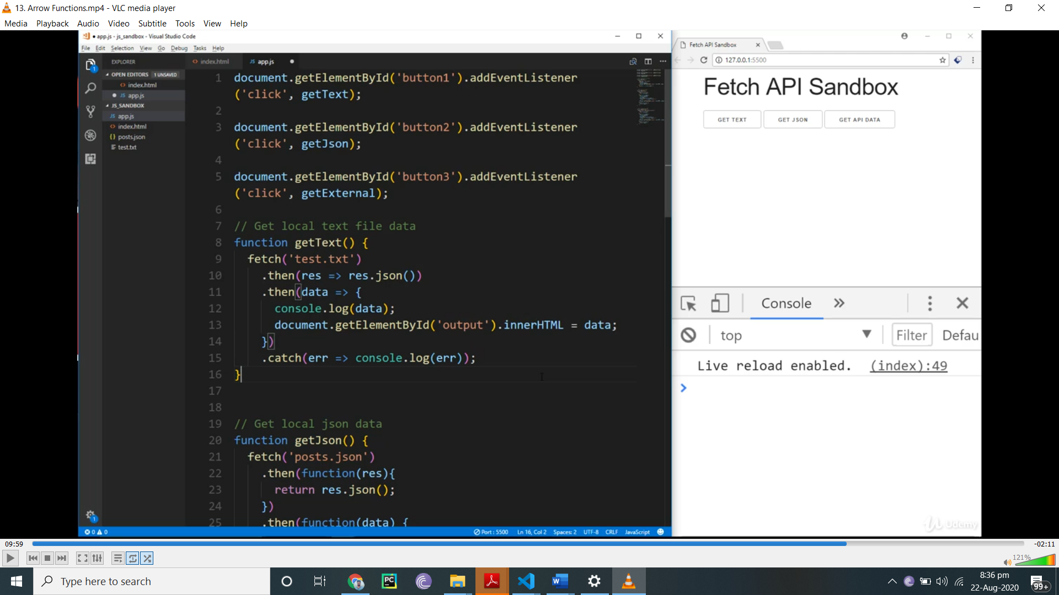

Error handling

fetch('https://devcamper.io/api/v1/bootcamps/34343')

  .then(res => res.json())

  .then(res => {

if (!res.ok) {

throw new Error(res.error);

}

return res;

})

  .catch(err => console.log(err));

I would suggest creating a separate function for error handling

function handleErrors(res) {

  if (!res.ok) throw new Error(res.error);

  return res;

}

fetch('https://devcamper.io/api/v1/bootcamps/34343')

  .then(res => res.json())

  .then(handleErrors)

  .then(res => console.log(res.data))

  .catch(err => console.log(err));

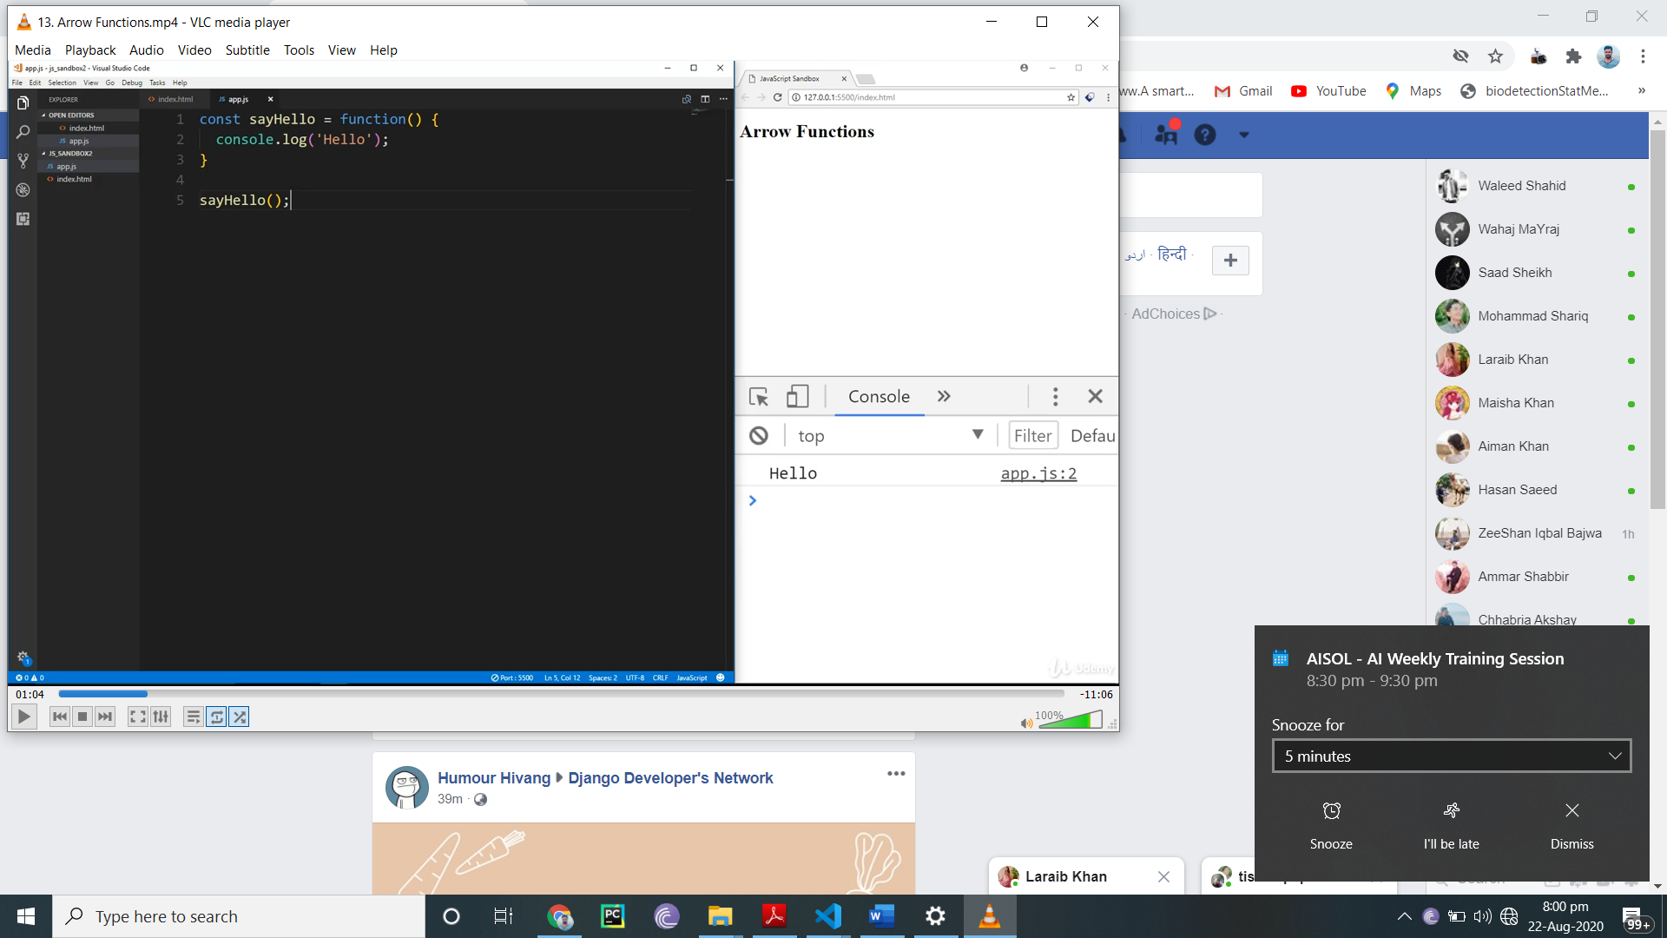

Arrow function

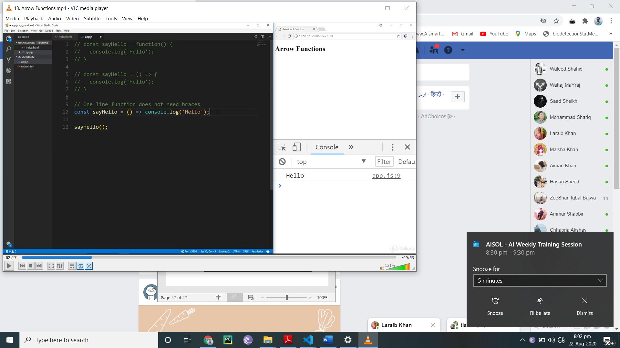

How to return

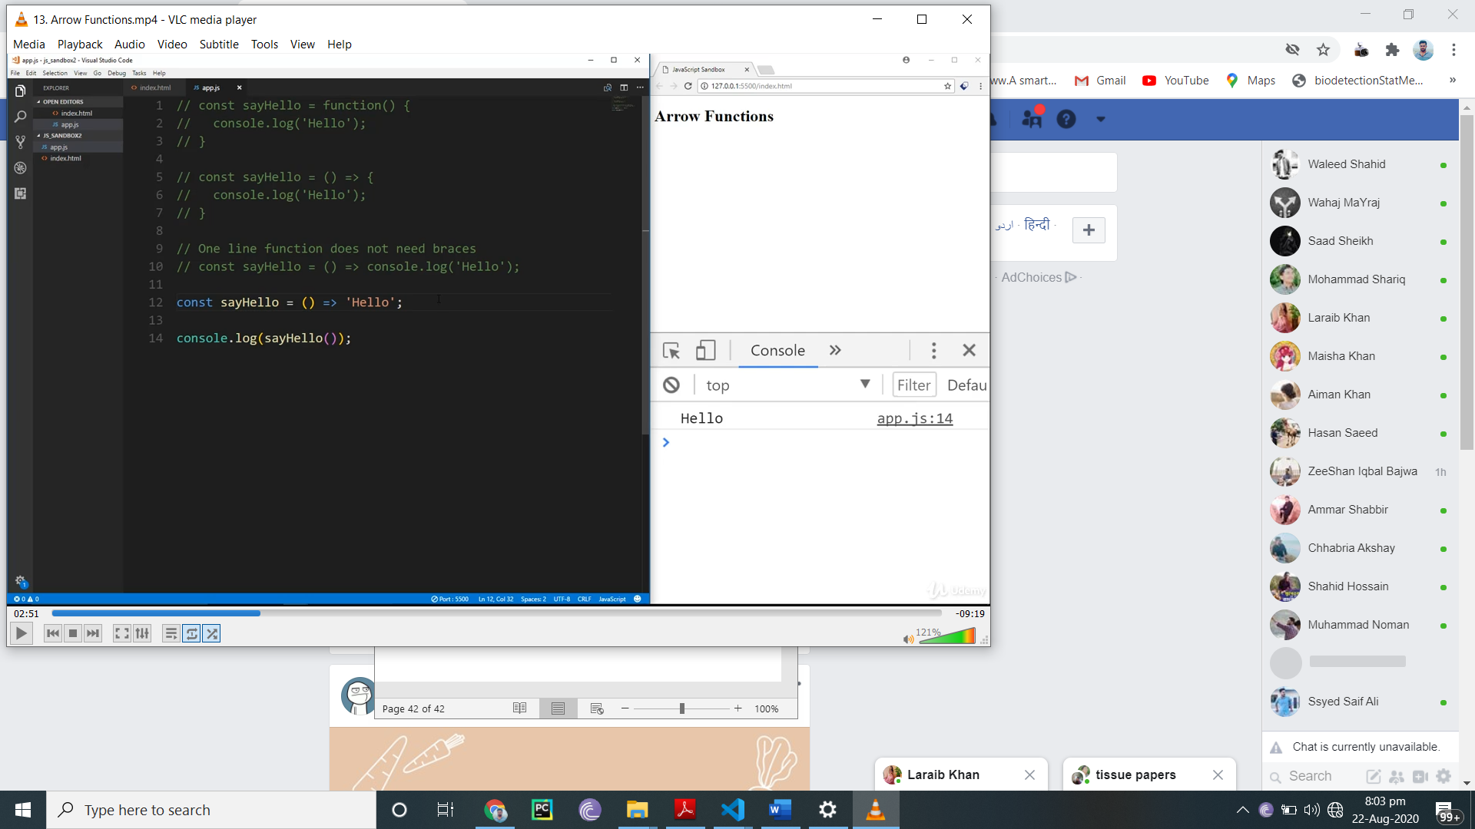

Return object

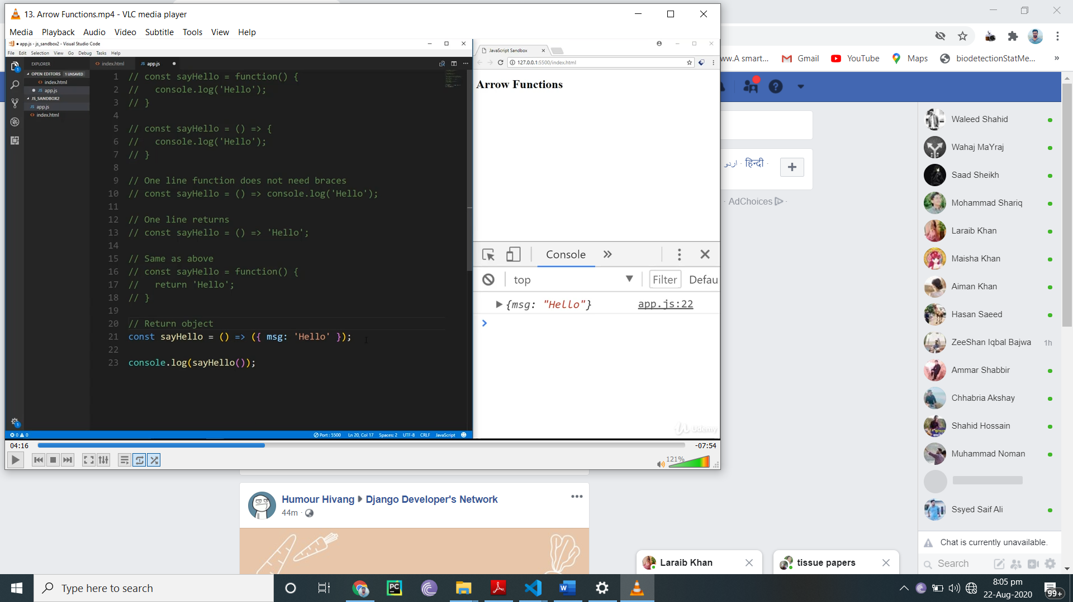

Passs aurgment and paramater

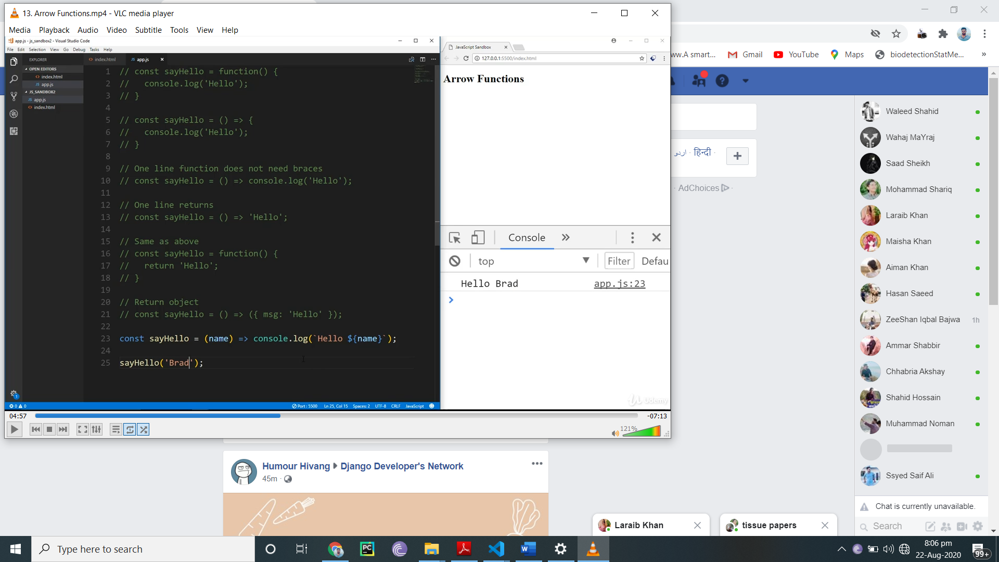

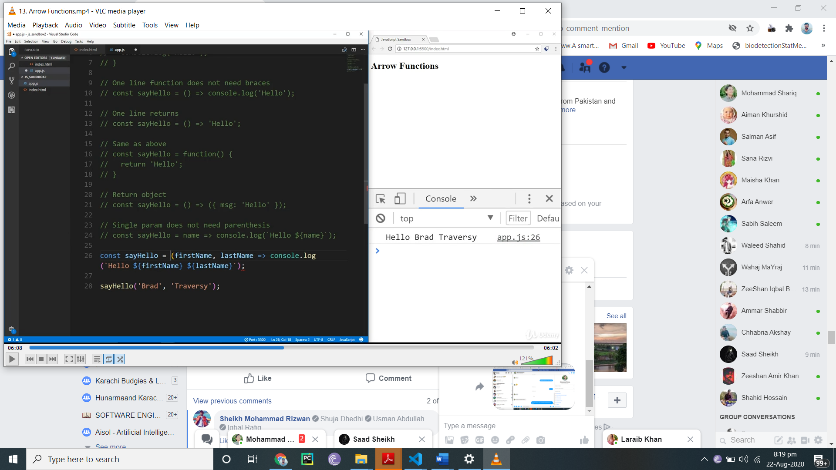

Map

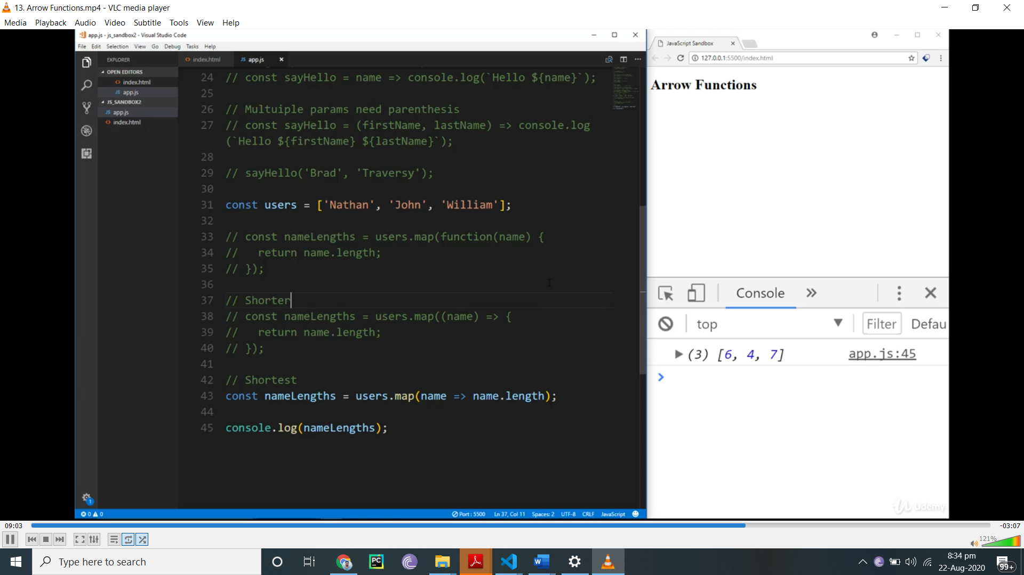

Wait

